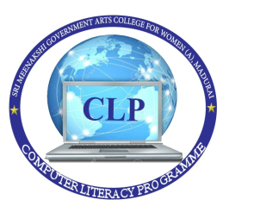
Sri Meenakshi Government Arts College for Women
(Autonomous)
(Affiliated to Madurai Kamaraj University)
Madurai – 625002
(Re-Accredited with “A” GRADE 3rd CYCLE by NAAC)

COMPUTER LITERACY PROGRAMME

Internal Audit External Audit Principal

Vision

To uplift the socially backward and economically poor young women of the society and empower them by imparting knowledge through holistic education, making them independent and responsible citizens to contribute to the development of the society.

Mission
- To undergo accreditation periodically.
- To identify our own strengths and weaknesses.
- To add to our strengths and eliminate weaknesses.
- To modernize the Teaching-Learning Process and to promote research culture.
- To encourage innovations and accountability.
- To encourage consultancy services and training.

Objectives

- To introduce the basic concepts of computer and networking Technology.
- To Provide Hands-on training in MS-Office Package and Internet Browsing.
- To impart Technological Skills for employability.

TABLE OF CONTENTS

S.NO | CONTENTS | PAGE.NO
1 | Introduction | 1
2 | CLP Syllabus | 2
3 | Yearwise Report | 5
4 | Staff Profile | 12
5 | Students Report | 17
6 | Lab Equipments Report | 18
7 | Students Photos | 26
8 | CLP Certificate | 39

INTRODUCTION

COMPUTER LITERACY PROGRAMME
Computer Literacy Programme was initiated by the Government of Tamilnadu in all Government Colleges to enrich all Undergraduate Non-Computer Science students from the year 2000-2001. This course was exclusively designed and geared with updated systems orienting towards providing the required knowledge to the students and for their upliftments in computer literacy. This course has been conducted for students from all disciplines except computer science.
Initially, a separate lab was established with 25 computers and other necessary equipments and a certificate course was being conducted in collaboration with NIIT, Madurai, under a contract period of 5 years.
In the year 2005-2006, the CLP lab with all equipments was handed over to the college by NIIT and thereafter course had been conducted successfully for all the first year under graduate students. This one year course is being offered for Rs.700/- with 90 practical hours and 60 theory hours. An Examination is conducted by the Directorate of Collegiate Education, Chennai at the end of the course and a valid certificate is issued.
Right now, there are around 1405 students from 13 departments on roll and classes are held from 9.00 am to 5.00 pm on all college working days.
Benefits of CLP:
• The Computer Literacy Programme is being conducted for Non-computer science students.
• The students are being trained on the state-of-art technologies both theoretically and practically.
• The orientation of the training is towards job fetching in the IT market with renowned skills in recent developments

CLP SYLLABUS

- Break up of Theory and Practical hours

S.No | Subject | Theory | Lab
1. | Introduction to computers | 6 | 0
2. | Operating system: concepts Win 98, win 2000/2003, win NT,Linux | 6 | 0
3. | Personal Productivity software: Ms Word/ Ms Excel | 10 | 20
4. | Personal Productivity software: Ms Access/ Ms Powerpoint | 10 | 20
5. | Introduction to Multimedia | 2 | 4
6. | Desktop Publishing | 4 | 10
7. | Networking concepts | 4 | 4
8. | Internet and its Application | 4 | 10
9. | Creating Web pages | 6 | 10
10. | Introduction to Tamil word Processor-Tamil Browser and Tamil E-mail. | 8 | 12
 | Total | 60 | 90

- Detailed Syllabus

UNIT I: ( Introduction to computers )

What is a computer?, history of computers, generation of computer, Types of computers, Benefits and applications of computers,
Components and working of computers: The Hardware, Computer Block diagram, Input, Output device,
Hardware Configuration & Software Installation: Concepts, Managing Hardware, inside the system unit, Memory, Storage media
Introduction to software, Data Organization, Cyber Laws

UNIT II : (Operating system: concepts Win 98, win 2000/2003,
win NT,Linux)

Win 98: Introduction and advantages, Files, Organization of data, Windows Explorer, Working with Folders, Managing Files, Folders, Find Files, Folders, Sharing a Folder, Creating Shortcuts. Using applications in Win 98, System Tools (Control panel), Shutdown
Win NT, Win 2000, Win 2003: User Interface, features, shutdown
Linux: History, Advantages, Logging in/out, File system, Types of users, directory commands.

UNIT III : ( Personal Productivity software: Ms Word/ Ms Excel )

Ms Office: Basic concepts, Features Editor
Ms Word: Introduction to word 2000, formatting Documents, Inserting Objects, Creating Tables, Mail merge
Ms Excel: Introduction to Excel 2000, Function and function Wizards, formula, formatting, chart & Objects.

UNIT IV:( Personal Productivity software: Ms Access/ Ms Powerpoint)

Ms Access: concepts of DBMS/RDBMS,Creating Databases & Tables Modifying the database, Data Retrieval, Relationship, Reports
Ms Powerpoint: Basic Concepts, Creating/Saving/Closing presentations, Formatting, Inserting Clip art, Transition Effects, Animation Effects, Viewing Presentation.

UNIT V: (Introduction to Multimedia)

Multimedia Uses, Categories, Multimedia Software, Sounds and Pictures Use of sound and Images in multimedia Application, Virtual Reality.

UNIT VI (Desktop Publishing)

Introduction, Publisher Environment, Help Options, creating Publication, Page Properties, Using Text Frames, adding Pictures, Formatting and Editing, Text using Tools, Multi page Publication.

UNIT VII (Networking concepts)

Basic concepts, Need for networking, Types of network, OSI Model, networking Devices, topology, Bus, star, Ring protocols, TCP/IP, Network configuration and Security, network Administration.

UNIT VIII (Internet and its Application)

Basic concepts, Origin of Internets, ISP, Domain Naming system, ISDN and PPP, TCP/IP, Introduction to different types of Browsers
E-mail and FTP: Introduction, Email Fundamentals, Email client and server, Email Address, Sending and receiving email, Inter tools and FTP usage.

UNIT IX (Creating Web pages)

Introduction, Tools for web Development, Introduction to HTML, HTML tage, Structure of an HTML Document, Creating a simple HTML page, Formatting the web page, Body Element, Information type Elements, Character Formatting Elements, Hyperlinks, Image Elements, Front Page.

UNIT X (Introduction to Tamil word Processor-Tamil Browser and Tamil
E-mail)

Ponmozhi, padhami (sakthi office)
Introduction to Tamil Browsers using suitable software
Introduction to Tamil E-mail using suitable software.

COMPUTER LITERACY PROGRAMME

YEARWISE REPORT
(2014-2015)

STUDENT DETAILS

STUDENTS STRENGTH | PRESENT | PASS | ABSENT | STUDENT PASS PERCENTAGE
1066 | 990 | 990 | Nil | 100

STAFF DETAILS

S.NO | STAFF NAME | QUALIFICATION | DOJ
1 | Mrs.G.ARUNA DEVI | M.Sc.,M.Phil.,B.L.I..S.c | 30.05.2005
2 | Mrs.M.KAMAKSHI KARTHIGA | BE., | 13.09.2006
3 | Mrs.J.JEYANAGAJOTHI | MCA.,M.Phil., | 18.09.2008
4 | Mrs.M.SELVA SUGUNA | MCA.,M.Phil., | 01.09.2010
5 | Ms.S.P.AARTHY | MCA., | 05.01.2013
6 | Ms.N.SARANYA RANI | MCA., | 01.08.2014
7 | Ms. N.SENTHILNAYAKI | MCA., | 01.08.2014
8 | Ms.K.CHITRA | MCA., | 01.09.2014
9 | Ms.S.ASHMA BENAZIR | MCA., | 10.12.2014

COMPUTER LITERACY PROGRAMME

YEARWISE REPORT
(2015-2016)

STUDENT DETAILS

STUDENTS STRENGTH | PRESENT | PASS | ABSENT | STUDENT PASS PERCENTAGE
1073 | 997 | 863 | 79 | 86.5

STAFF DETAILS

S.NO | STAFF NAME | QUALIFICATION | DOJ
1 | Mrs.G.ARUNA DEVI | M.Sc.,M.Phil.,B.L.I..S.c | 30.05.2005
2 | Mrs.M.KAMAKSHI KARTHIGA | BE., | 13.09.2006
3 | Mrs.J.JEYANAGAJOTHI | MCA.,M.Phil., | 18.09.2008
4 | Mrs.M.SELVA SUGUNA | MCA.,M.Phil., | 01.09.2010
5 | Ms.S.P.AARTHY | MCA., | 05.01.2013
6 | Ms.N.SARANYA RANI | MCA., | 01.08.2014
7 | Ms. N.SENTHILNAYAKI | MCA., | 01.08.2014
8 | Ms.K.CHITRA | MCA., | 01.09.2014
9 | Ms.S.ASHMA BENAZIR | MCA., | 10.12.2014
10 | Ms.T.NAGAJOTHI | MCA., | 02.09.2015

COMPUTER LITERACY PROGRAMME

YEARWISE REPORT
(2016-2017)

STUDENT DETAILS

STUDENTS STRENGTH | PRESENT | PASS | ABSENT | STUDENT PASS PERCENTAGE
1163 | 1056 | 931 | 19 | 88

STAFF DETAILS

S.NO | STAFF NAME | QUALIFICATION | DOJ
1 | Mrs.G.ARUNA DEVI | M.Sc.,M.Phil.,B.L.I..S.c | 30.05.2005
2 | Mrs.M.KAMAKSHI KARTHIGA | BE., | 13.09.2006
3 | Mrs.J.JEYANAGAJOTHI | MCA.,M.Phil., | 18.09.2008
4 | Mrs.M.SELVA SUGUNA | MCA.,M.Phil., | 01.09.2010
5 | Ms.S.P.AARTHY | MCA., | 05.01.2013
6 | Ms.N.SARANYA RANI | MCA., | 01.08.2014
7 | Ms. N.SENTHILNAYAKI | MCA., | 01.08.2014
8 | Ms.K.CHITRA | MCA., | 01.09.2014
9 | Ms.S.ASHMA BENAZIR | MCA., | 10.12.2014
10 | Ms.T.NAGAJOTHI | MCA., | 02.09.2015
11 | Ms.S.GUNASUNDARI | MCA., | 04.08.2016

COMPUTER LITERACY PROGRAMME

YEARWISE REPORT
(2017-2018)

STUDENT DETAILS

STUDENTS STRENGTH | PRESENT | PASS | ABSENT | STUDENT PASS PERCENTAGE
1245 | 1214 | 1131 | 48 | 93.2

STAFF DETAILS

S.NO | STAFF NAME | QUALIFICATION | DOJ
1 | Mrs.G.ARUNA DEVI | M.Sc.,M.Phil.,B.L.I..S.c | 30.05.2005
2 | Mrs.M.KAMAKSHI KARTHIGA | BE.,M.Tech., | 13.09.2006
3 | Mrs.J.JEYANAGAJOTHI | MCA.,M.Phil., | 18.09.2008
4 | Mrs.M.SELVA SUGUNA | MCA.,M.Phil., | 01.09.2010
5 | Mrs.S.P.AARTHY | MCA., | 05.01.2013
6 | Mrs.N.SARANYA RANI | MCA., | 01.08.2014
7 | Mrs. N.SENTHILNAYAKI | MCA., | 01.08.2014
8 | Ms.S.ASHMA BENAZIR | MCA., | 10.12.2014
9 | Ms.S.GUNASUNDARI | MCA., | 04.08.2016
10 | Mrs.A.ROSELINE REVATHY | M.Sc.,(IT) | 13.12.2017
11 | Ms.M.JEYAVANI | MCA.,M.Phil., | 13.12.2017
12 | Ms.A.SUNDARESWARI | M.Sc., | 14.12.2017

COMPUTER LITERACY PROGRAMME

YEARWISE REPORT
(2018-2019)

STUDENT DETAILS

STUDENTS STRENGTH | PRESENT | PASS | ABSENT | STUDENT PASS PERCENTAGE
1322 | 1149 | 1103 | 42 | 96

STAFF DETAILS

S.NO | STAFF NAME | QUALIFICATION | DOJ
1 | Mrs.G.ARUNA DEVI | M.Sc.,M.Phil.,B.L.I..S.c | 30.05.2005
2 | Mrs.M.KAMAKSHI KARTHIGA | BE.,M.Tech., | 13.09.2006
3 | Mrs.J.JEYANAGAJOTHI | MCA.,M.Phil., | 18.09.2008
4 | Mrs.M.SELVA SUGUNA | MCA.,M.Phil., | 01.09.2010
5 | Mrs.S.P.AARTHY | MCA., | 05.01.2013
6 | Mrs.N.SARANYA RANI | MCA., | 01.08.2014
7 | Mrs. N.SENTHILNAYAKI | MCA., | 01.08.2014
8 | Ms.S.ASHMA BENAZIR | MCA., | 10.12.2014
9 | Ms.S.GUNASUNDARI | MCA., | 04.08.2016
10 | Mrs.A.ROSELINE REVATHY | M.Sc.,(IT) | 13.12.2017
11 | Ms.M.JEYAVANI | MCA.,M.Phil., | 13.12.2017
12 | Ms.A.SUNDARESWARI | M.Sc., | 14.12.2017

COMPUTER LITERACY PROGRAMME

YEARWISE REPORT
(2019-2020)

STUDENT DETAILS

STUDENTS STRENGTH | STATUS
1304 | Waiting for Exam

STAFF DETAILS

S.NO | STAFF NAME | QUALIFICATION | DOJ
1 | Mrs.G.ARUNA DEVI | M.Sc.,M.Phil.,B.L.I..S.c | 30.05.2005
2 | Mrs.M.KAMAKSHI KARTHIGA | BE., M.Tech., | 13.09.2006
3 | Mrs.J.JEYANAGAJOTHI | MCA.,M.Phil., | 18.09.2008
4 | Mrs.M.SELVA SUGUNA | MCA.,M.Phil., | 01.09.2010
5 | Mrs.S.P.AARTHY | MCA., | 05.01.2013
6 | Mrs.N.SARANYA RANI | MCA., | 01.08.2014
7 | Mrs. N.SENTHILNAYAKI | MCA., | 01.08.2014
8 | Ms.S.ASHMA BENAZIR | MCA., | 10.12.2014
9 | Ms.S.GUNASUNDARI | MCA., | 04.08.2016
10 | Mrs.A.ROSELINE REVATHY | M.Sc.,(IT) | 13.12.2017
11 | Mrs.M.JEYAVANI | MCA.,M.Phil., | 13.12.2017
12 | Ms.A.SUNDARESWARI | M.Sc., | 14.12.2017

COMPUTER LITERACY PROGRAMME

YEARWISE REPORT
(2020-2021)

STUDENT DETAILS

STUDENTS STRENGTH | STATUS
1371 | Waiting for Exam

STAFF DETAILS

S.NO | STAFF NAME | QUALIFICATION | DOJ
1 | Mrs.G.ARUNA DEVI | M.Sc.,M.Phil.,B.L.I..S.c | 30.05.2005
2 | Mrs.M.KAMAKSHI KARTHIGA | BE., M.Tech., | 13.09.2006
3 | Mrs.J.JEYANAGAJOTHI | MCA.,M.Phil., | 18.09.2008
4 | Mrs.M.SELVA SUGUNA | MCA.,M.Phil., | 01.09.2010
5 | Mrs.S.P.AARTHY | MCA., | 05.01.2013
6 | Mrs.N.SARANYA RANI | MCA., | 01.08.2014
7 | Mrs.N.SENTHILNAYAKI | MCA., | 01.08.2014
8 | Mrs.A.ROSELINE REVATHY | M.Sc.,(IT) | 13.12.2017
9 | Mrs.M.JEYAVANI | MCA.,M.Phil., | 13.12.2017
10 | Mrs.A.SUNDARESWARI | M.Sc., | 14.12.2017

STAFF DETAILS
BIO-DATA

Name : Mrs.G.Aruna devi
Date of Birth : 26.05.1982
Age : 39
Qualification : M.Sc.,M.Phil.,B.L.I.Sc
Community : BC
Caste : Yadhava
Date of Joining : 30.05.2005
Experience : 16 Years 11 Months
E-mail ID : arunadevi26@gmail.com
Phone number : 9585222210

BIO-DATA

Name : Mrs.M.Kamakshi Karthiga
Date of Birth : 03.11.1982
Age : 39
Qualification : B.E.,M.Tech.,
Community : BC
Caste : Thuluva Vellala
Date of Joining : 13.09.2006
Experience : 15 Years 7 Months
E-mail ID : kamakshi.smgcclp@gmail.com
Phone Number : 8883637383

BIO-DATA

Name : Mrs.J.Jeyanagajothi
Date of Birth : 02.10.1985
Age : 36
Qualification : MCA.,M.Phil.,
Community : BC
Caste : Reddy-Ganjam
Date of Joining : 18.09.2008
Experience : 13 Years 7 Months
E-mail ID : jjeya06@gmail.com
Phone number : 7708007847

BIO-DATA

Name : Mrs.M.Selva Suguna
Date of Birth : 05.02.1985
Age : 37
Qualification : MCA.,M.Phil.,
Community : BC
Caste : Nadar
Date of Joining : 01.09.2010
Experience : 11 Years 6 Months
E-mail ID : sugunamano85@gmail.com
Phone number : 9626742252

BIO-DATA

Name : Mrs.S.P.Aarthy
Date of Birth : 24.10.1988
Age : 33
Qualification : MCA.,
Community : BC
Caste : Kallar
Date of Joining : 05.01.2003
Experience : 9 Years 4 Months
E-mail ID : aarthy2423@gmail.com
Phone number : 7708964322

BIO-DATA

Name : Mrs.N.Saranya Rani
Date of Birth : 06.01.1987
Age : 35
Qualification : MCA.,
Community : BC
Caste : Thuluva Vellala
Date of Joining : 01.08.2014
Experience : 7 Years 9 Months
E-mail ID : saranyaranin@gmail.com
Phone number : 7867083111

BIO-DATA

Name : Mrs.N.Senthilnayaki
Date of Birth : 22.10.1987
Age : 34
Qualification : MCA.,
Community : SC
Caste : Parayan
Date of Joining : 01.08.2014
Experience : 7 Years 9 Months
E-mail ID : nayaki22@gmail.com
Phone number : 9952845558

BIO-DATA

Name : Mrs.A.Roseline Revathy
Date of Birth : 13.03.1986
Age : 35
Qualification : M.Sc.,
Community : BC
Caste : Nadar
Date of Joining : 13.12.2017
Experience : 4 Years 4 Months
E-mail ID : revathyrose13@gmail.com
Phone number : 9003828322

BIO-DATA

Name : Mrs.A.Sundareswari
Date of Birth : 06.05.1994
Age : 27
Qualification : M.Sc.,
Community : BC
Caste : Nadar
Date of Joining : 14.12.2017
Experience : 4 Years 4 Months
E-mail ID : sundariviji1994@gmail.com
Phone number : 8124924839

Year | Students Strength | Present for Exam | Pass | Absent | Percentage
2014-2015 | 1066 | 990 | 990 | Nil | 100
2015-2016 | 1073 | 997 | 863 | 79 | 86.5
2016-2017 | 1163 | 1056 | 931 | 19 | 88
2017-2018 | 1245 | 1214 | 1131 | 48 | 93.2
2018-2019 | 1322 | 1149 | 1103 | 42 | 96
2019-2020 | 1304 | Waiting for Exam
2020-2021 | 1371 | Waiting for Exam

SRI MEENAKSHI GOVT. ARTS COLLEGE FOR WOMEN(A)

COMPUTER LITERACY PROGRAMME

STUDENT EXAM DETAILS 2014-2021

LAB EQUIPMENTS DETAILS

SL.NO | EQUIPMENTS | NO OF COUNT
1 | SYSTEM | 21
2 | XEROX MACHINE | 1
3 | D-LINK(MODEM) | 1

S.NO | EQUIPMENTS | DESCRIPTION | QUANTITY
1. | System | Processor : Intel®Core™ i5-3330 CPU  @ 3.00GHz 3.00GHz  Memory RAM : 4GB  System type : 64bit Operating System | 8
 |  | Processor : Intel®Core™ i5-650 CPU @  3.20GHz 3.19GHz  Memory RAM : 4GB  System type : 64bit Operating System | 11
 |  | Processor : Intel®Core™ 2 DUO CPU  E7500 @ 2.93GHz 2.93GHz  Memory RAM : 4GB  System type : 64bit Operating System | 2
2. | Printer | CANON Multifunctional Device  (Scan & Print) | 1
3. | Modem | D-Link Modem with Wi-Fi Router  Speed : 150 Mbps | 1

SYSTEM 1 : SYSTEM 2:

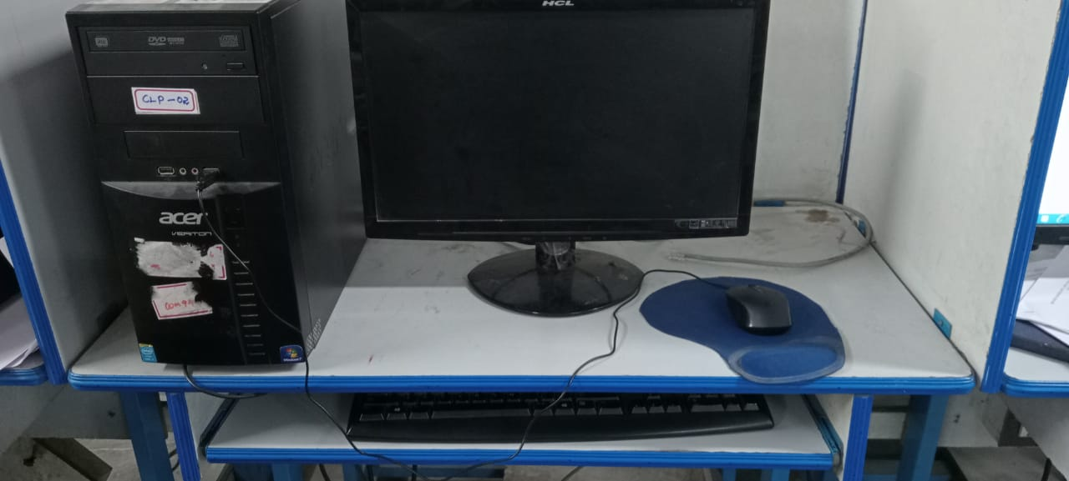
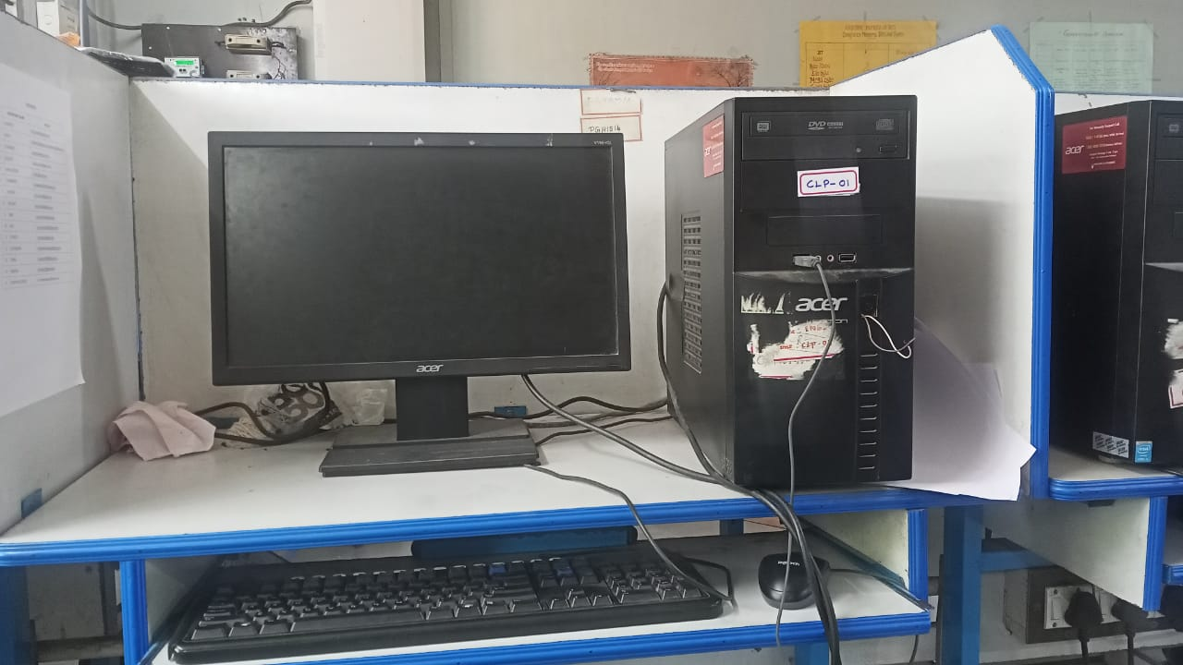
DESCRIPTION : DESCRIPTION :
Processor : Intel®Core™ i5-3330 CPU @ 3.00GHz 3.00GHz
Memory RAM : 4GB
System type : 64bit Operating System

Processor : Intel®Core™ i5-3330 CPU @ 3.00GHz 3.00GHz
Memory RAM : 4GB
System type : 64bit Operating System

SYSTEM 3: SYSTEM 4:

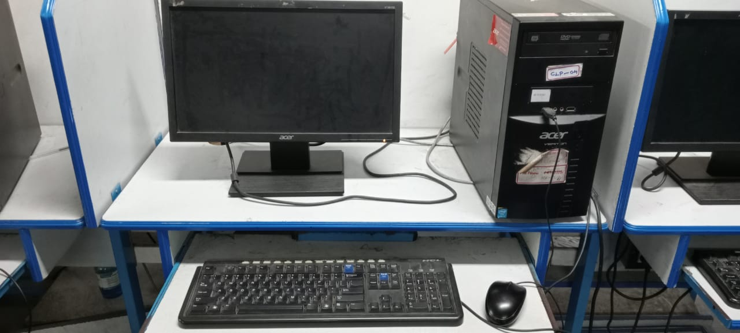
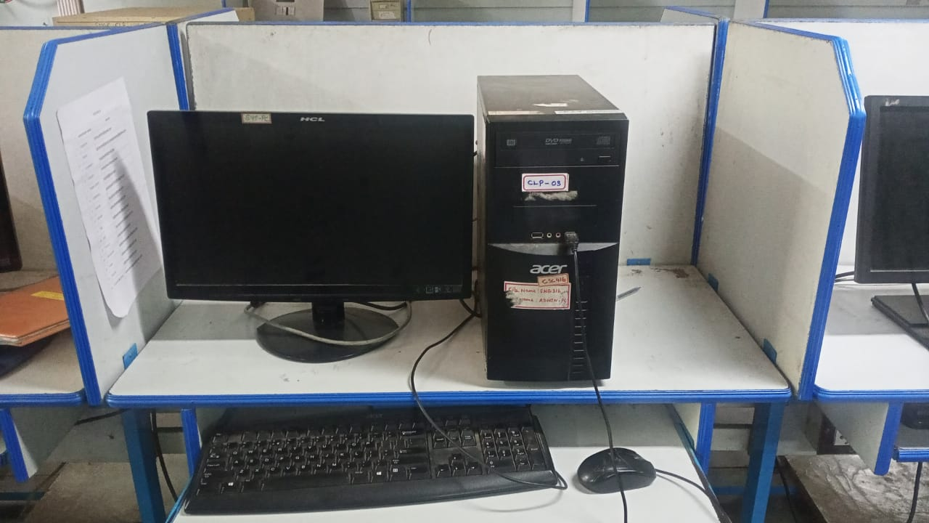
DESCRIPTION : DESCRIPTION :
Processor : Intel®Core™ i5-3330 CPU @ 3.00GHz 3.00GHz
Memory RAM : 4GB
System type : 64bit Operating System

Processor : Intel®Core™ i5-3330 CPU @ 3.00GHz 3.00GHz
Memory RAM : 4GB
System type : 64bit Operating System

SYSTEM 5: SYSTEM 6:

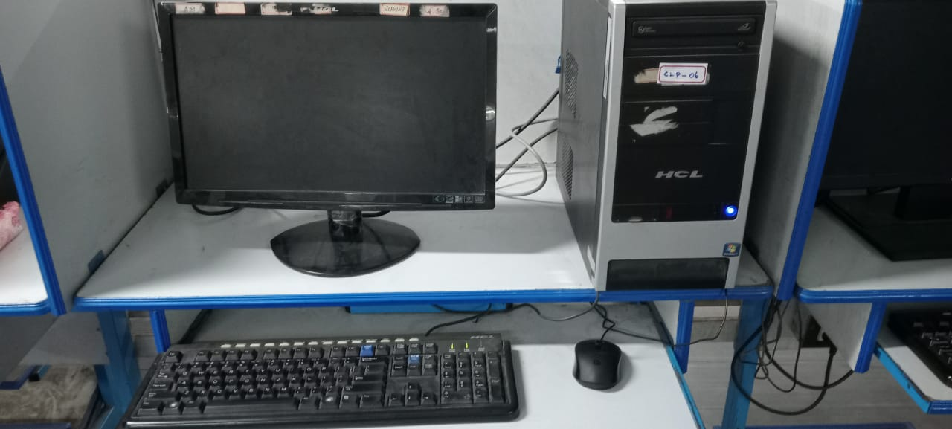
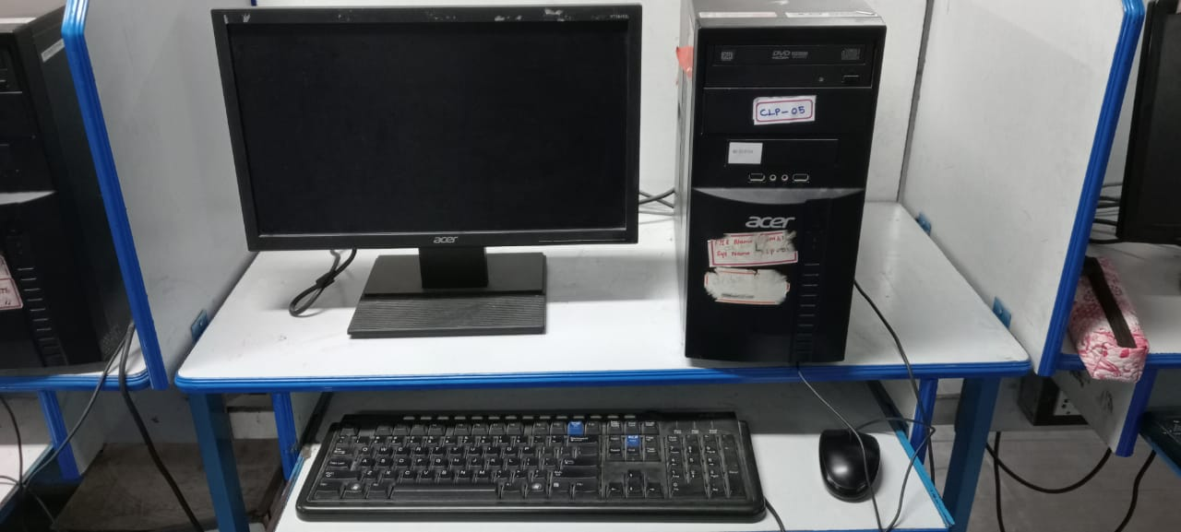
DESCRIPTION : DESCRIPTION :
Processor : Intel®Core™ i5-3330 CPU @ 3.00GHz 3.00GHz
Memory RAM : 4GB
System type : 64bit Operating System

Processor : Intel®Core™ i5-650 CPU @ 3.20GHz 3.19GHz
Memory RAM : 4GB
System type : 64bit Operating System

SYSTEM 7: SYSTEM 8:
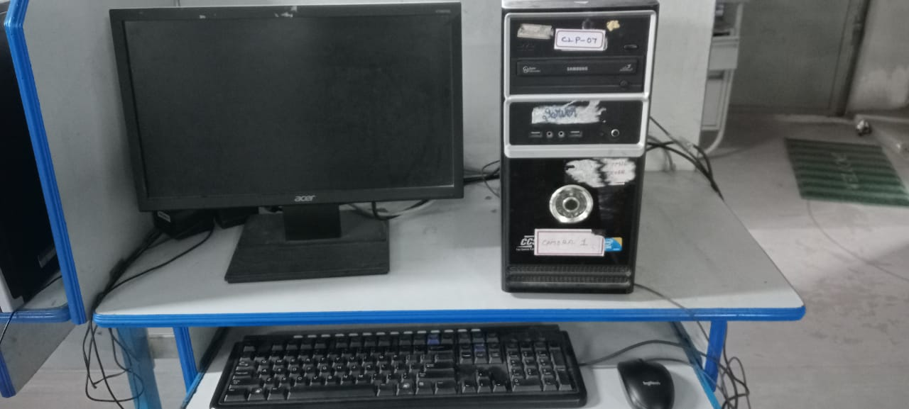
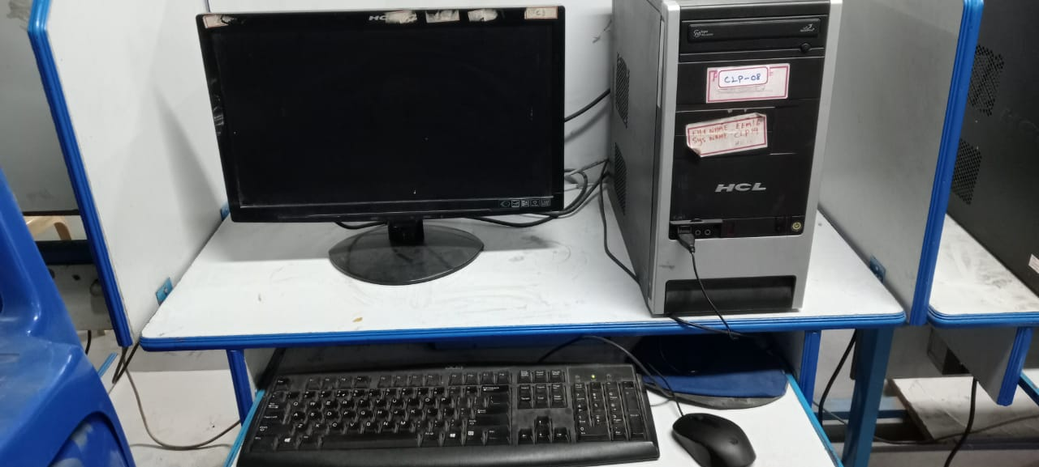
DESCRIPTION : DESCRIPTION :
Processor : Intel®Core™ 2 DUO CPU E7500 @ 2.93GHz 2.93GHz
Memory RAM : 4GB
System type : 64bit Operating System

Processor : Intel®Core™ i5-650 CPU @ 3.20GHz 3.19GHz
Memory RAM : 4GB
System type : 64bit Operating System

DESCRIPTION :

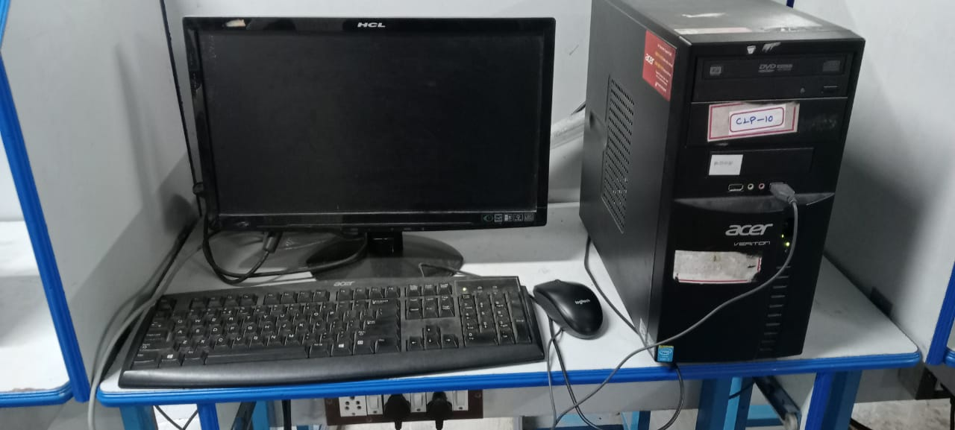
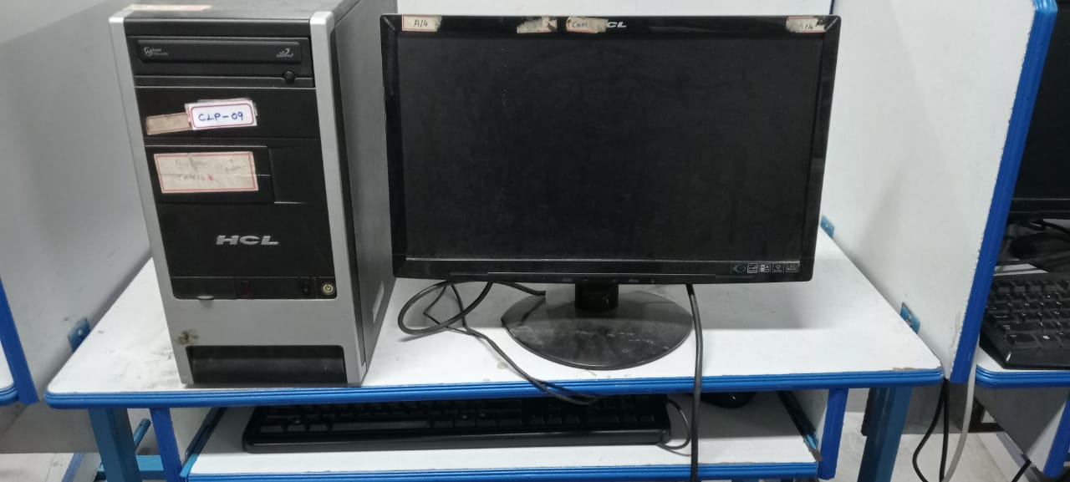
SYSTEM 9: SYSTEM 10:

DESCRIPTION : DESCRIPTION :
Processor : Intel®Core™ 2 DUO CPU E7500 @ 2.93GHz 2.93GHz
Memory RAM : 4GB
System type : 64bit Operating System

Processor : Intel®Core™ i5-650 CPU @ 3.20GHz 3.19GHz
Memory RAM : 4GB
System type : 64bit Operating System

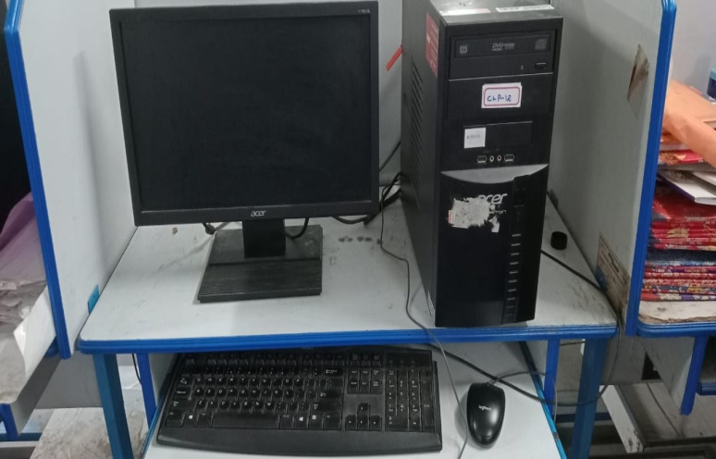
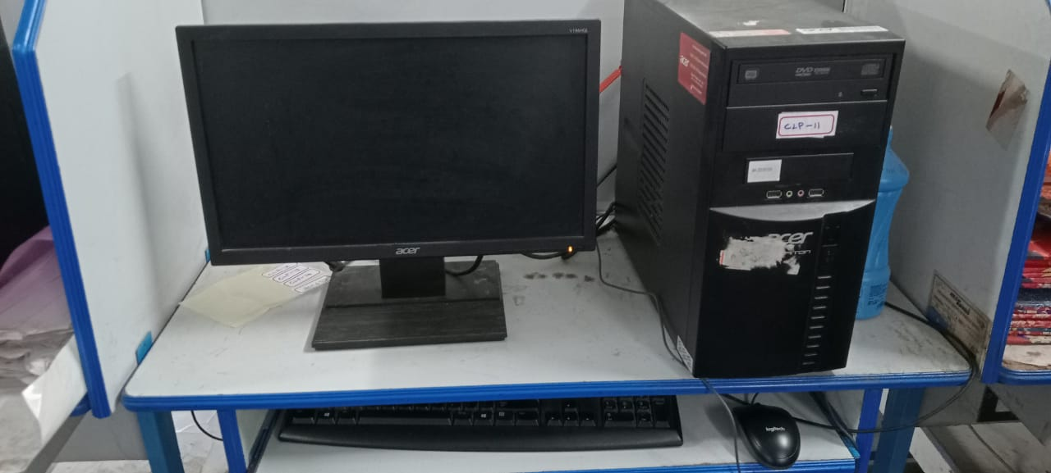
SYSTEM 11: SYSTEM 12:

DESCRIPTION : DESCRIPTION :
Processor : Intel®Core™ i5-3330 CPU @ 3.00GHz 3.00GHz
Memory RAM : 4GB
System type : 64bit Operating System

Processor : Intel®Core™ i5-3330 CPU @ 3.00GHz 3.00GHz
Memory RAM : 4GB
System type : 64bit Operating System

SYSTEM 13: SYSTEM 14:
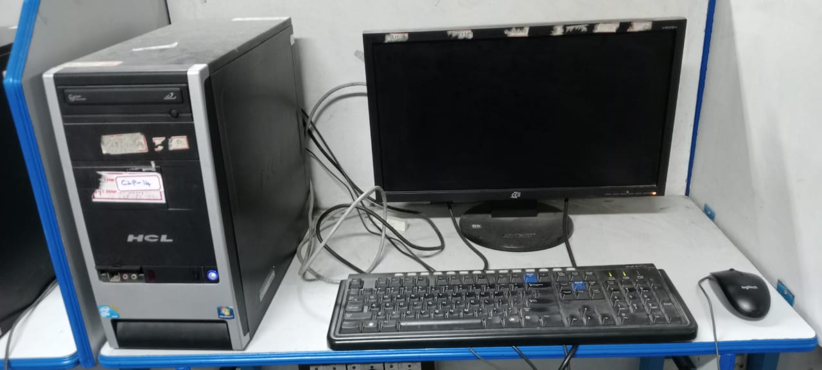
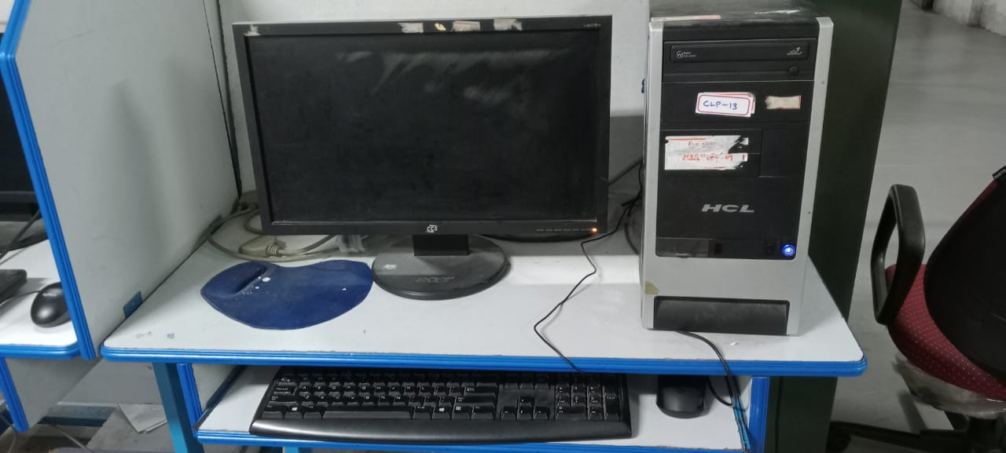

DESCRIPTION : DESCRIPTION :
Processor : Intel®Core™ i5-650 CPU @ 3.20GHz 3.19GHz
Memory RAM : 4GB
System type : 64bit Operating System

Processor : Intel®Core™ i5-650 CPU @ 3.20GHz 3.19GHz
Memory RAM : 4GB
System type : 64bit Operating System

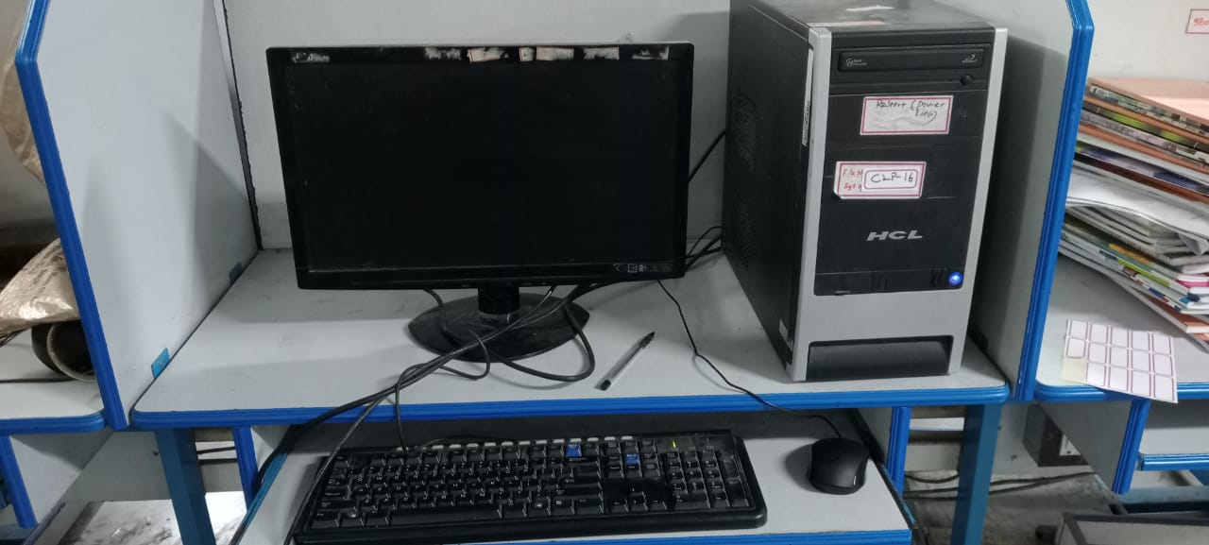
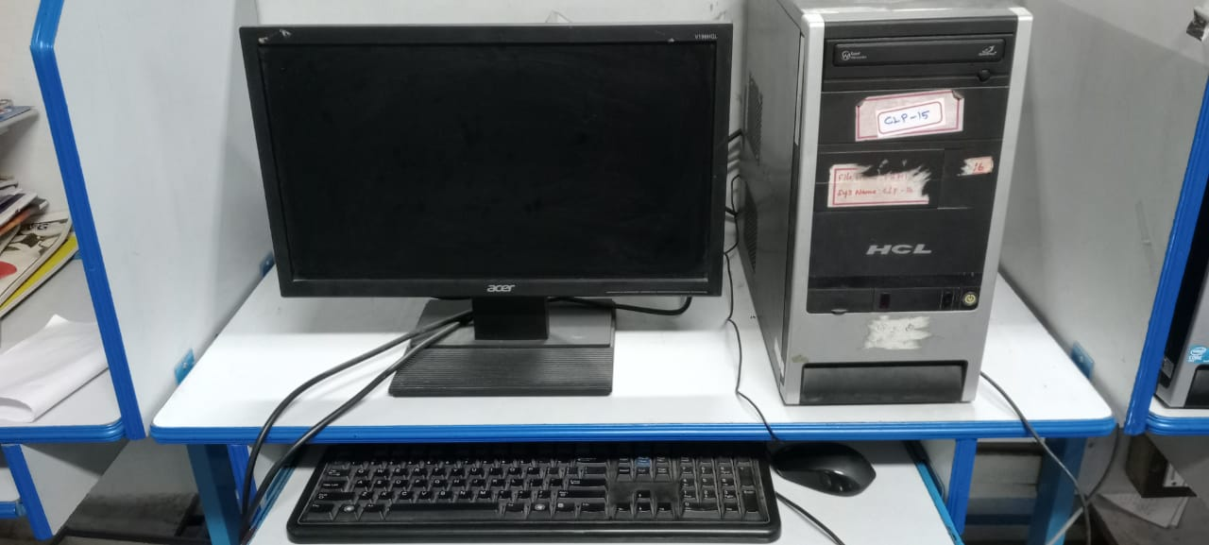
SYSTEM 15: SYSTEM 16:

DESCRIPTION :
Processor : Intel®Core™ i5-650 CPU @ 3.20GHz 3.19GHz
Memory RAM : 4GB
System type : 64bit Operating System

Processor : Intel®Core™ i5-650 CPU @ 3.20GHz 3.19GHz
Memory RAM : 4GB
System type : 64bit Operating System

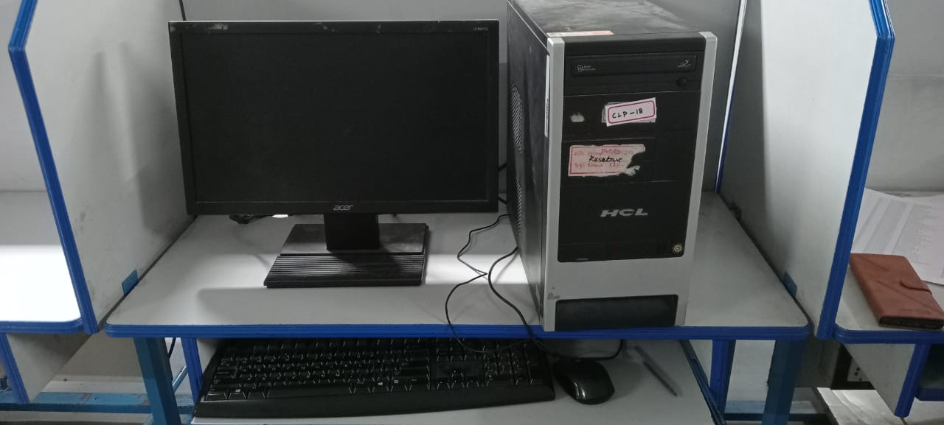
SYSTEM 17: SYSTEM 18:
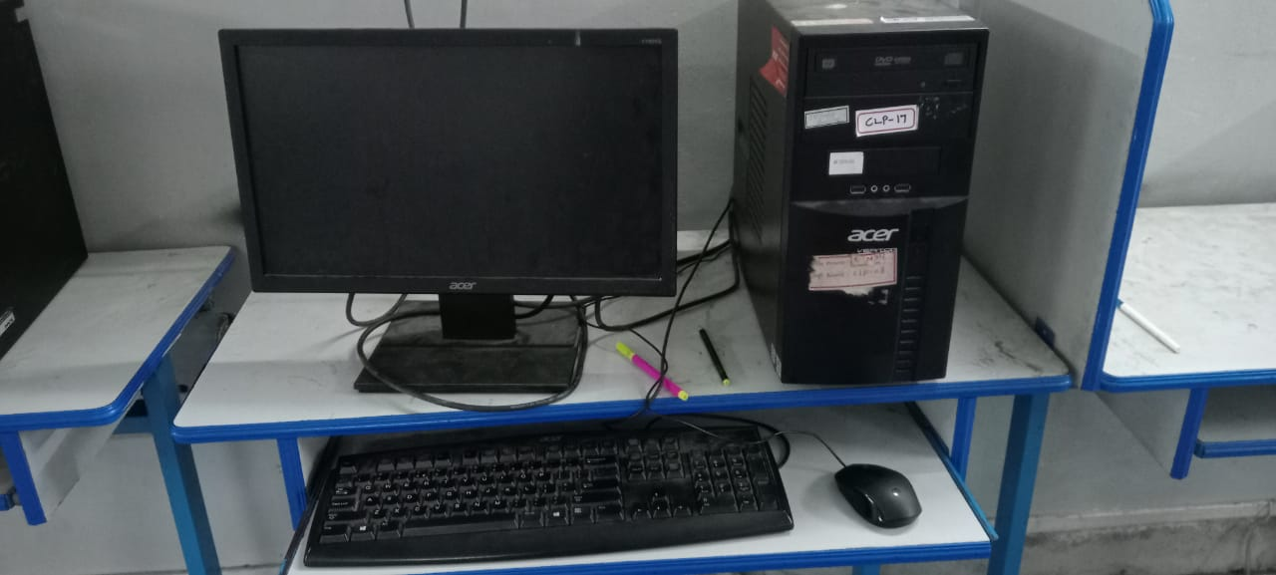
DESCRIPTION : DESCRIPTION :
Processor : Intel®Core™ i5-3330 CPU @ 3.00GHz 3.00GHz
Memory RAM : 4GB
System type : 64bit Operating System

Processor : Intel®Core™ i5-650 CPU @ 3.20GHz 3.19GHz
Memory RAM : 4GB
System type : 64bit Operating System

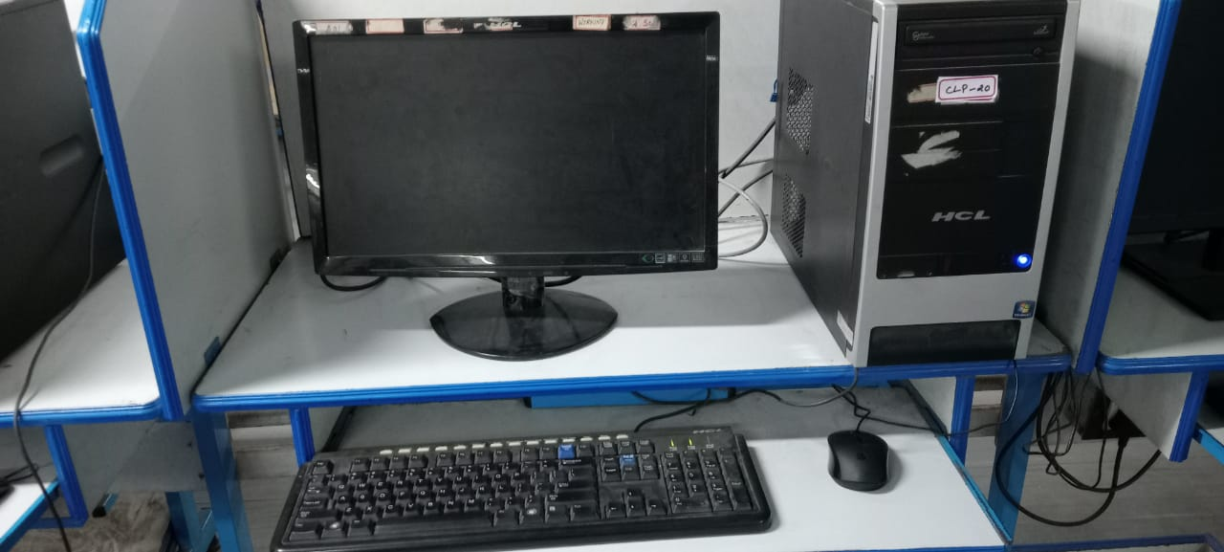
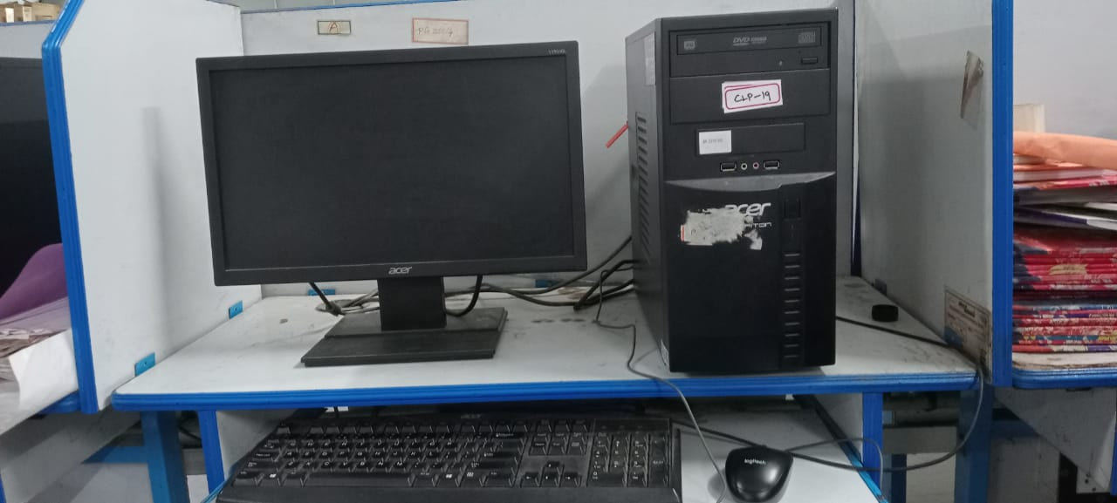
SYSTEM 19: SYSTEM 20:

DESCRIPTION : DESCRIPTION :
Processor : Intel®Core™ i5-650 CPU @ 3.20GHz 3.19GHz
Memory RAM : 4GB
System type : 64bit Operating System

Processor : Intel®Core™ i5-650 CPU @ 3.20GHz 3.19GHz
Memory RAM : 4GB
System type : 64bit Operating System

SYSTEM 21:

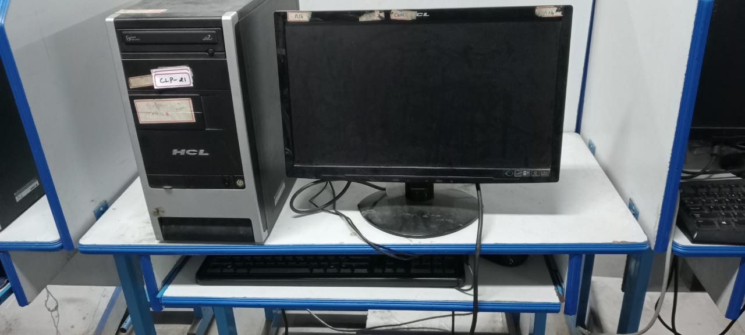
DESCRIPTION :
Processor : Intel®Core™ i5-650 CPU @ 3.20GHz 3.19GHz
Memory RAM : 4GB
System type : 64bit Operating System

MODEM

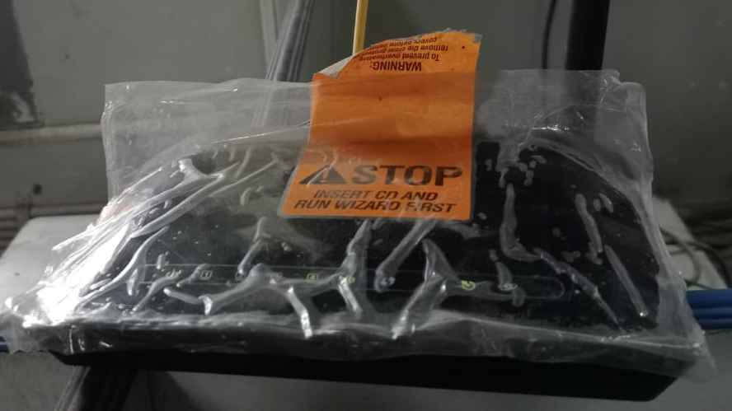

DESCRIPTION :
D-Link Model : DSL-2730U
Input : 12V-0.5A
IP : 192.168.1.1

CANON MULTIFUNCTIONAL DEVICE:
(SCAN & PRINT)

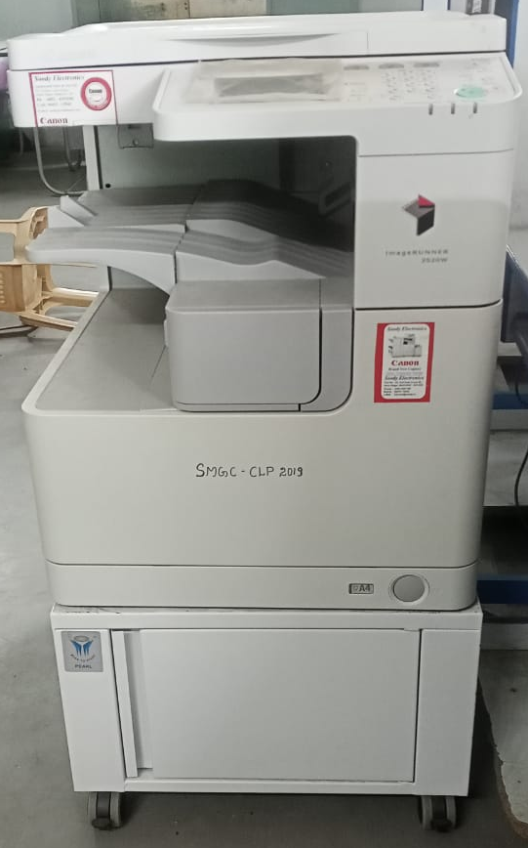

DESCRIPTION :
Model : Canon IR2520W Multifunctional Device
Serial No. : WMN06467
Mode : Black & White
Supported Paper size : A4, A3
Supported OS : Windows10, Windows7, Windows
Type : Desktop or Free standing (Reader-Printer Combined)

COMPUTER LITERACY PROGRAMME

2014 TO 2021 - PHOTOS

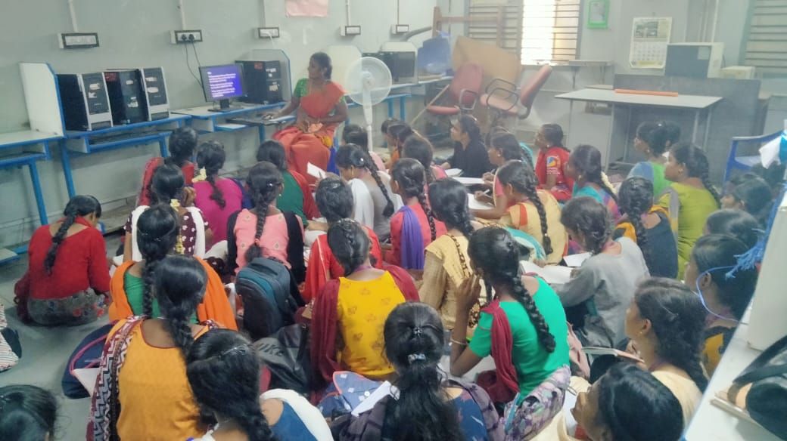

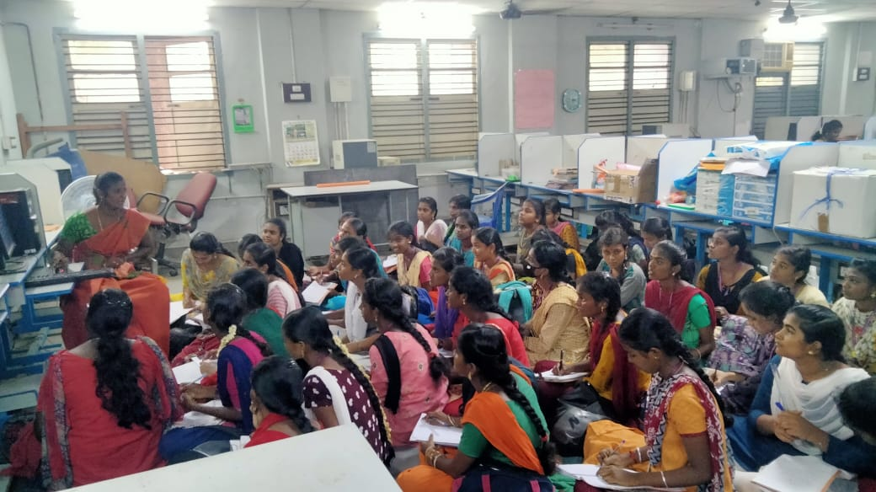

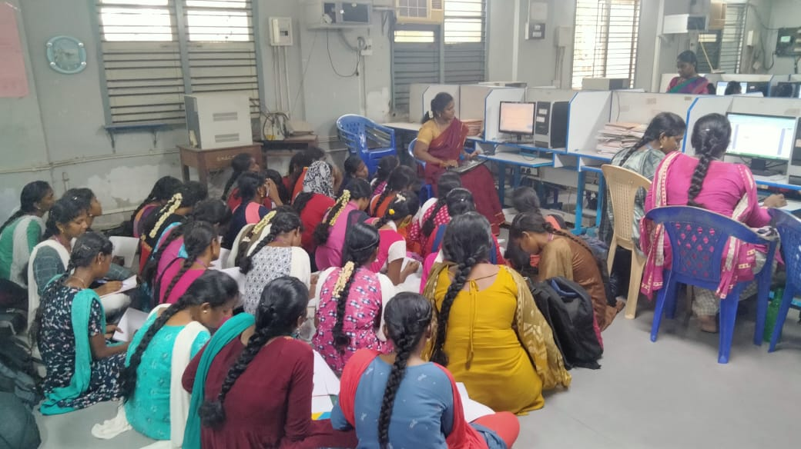

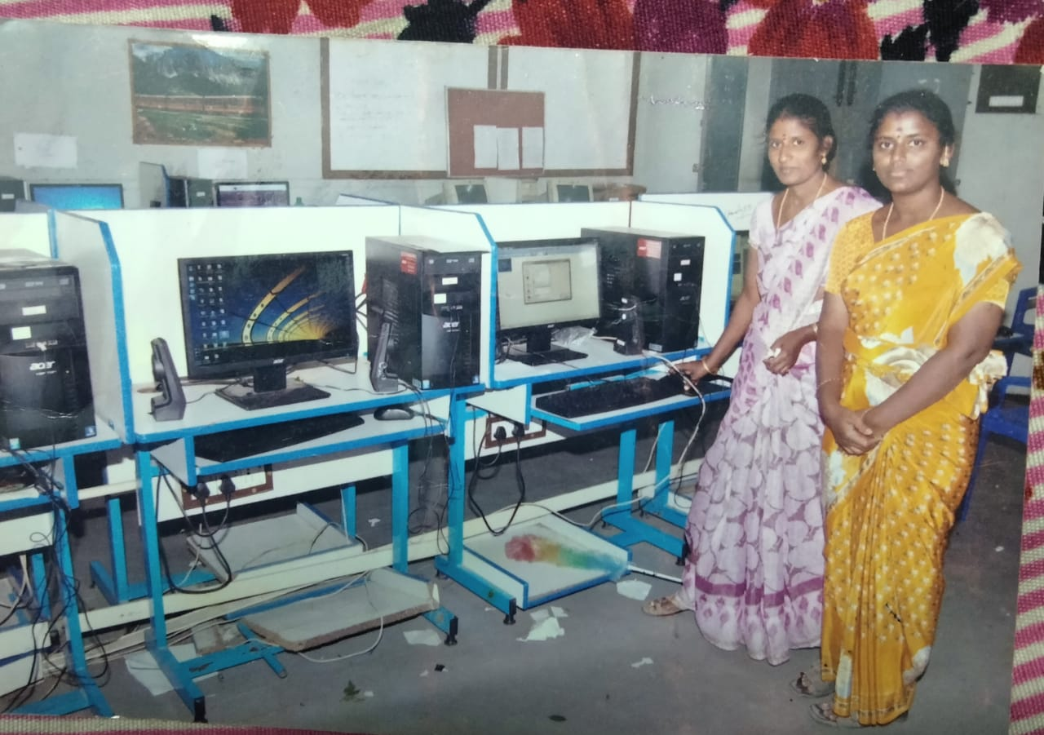

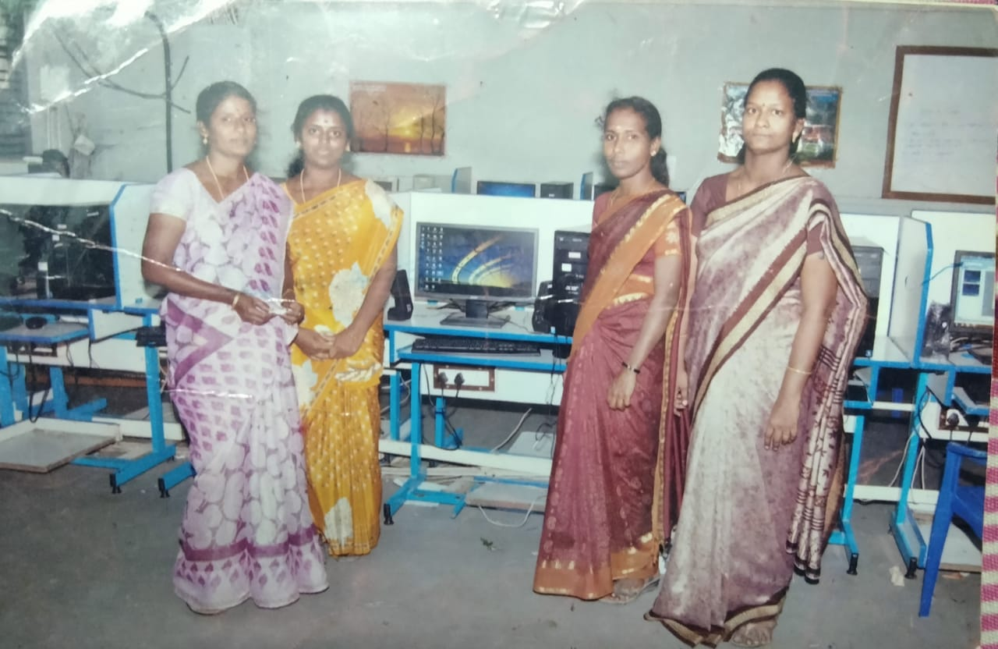

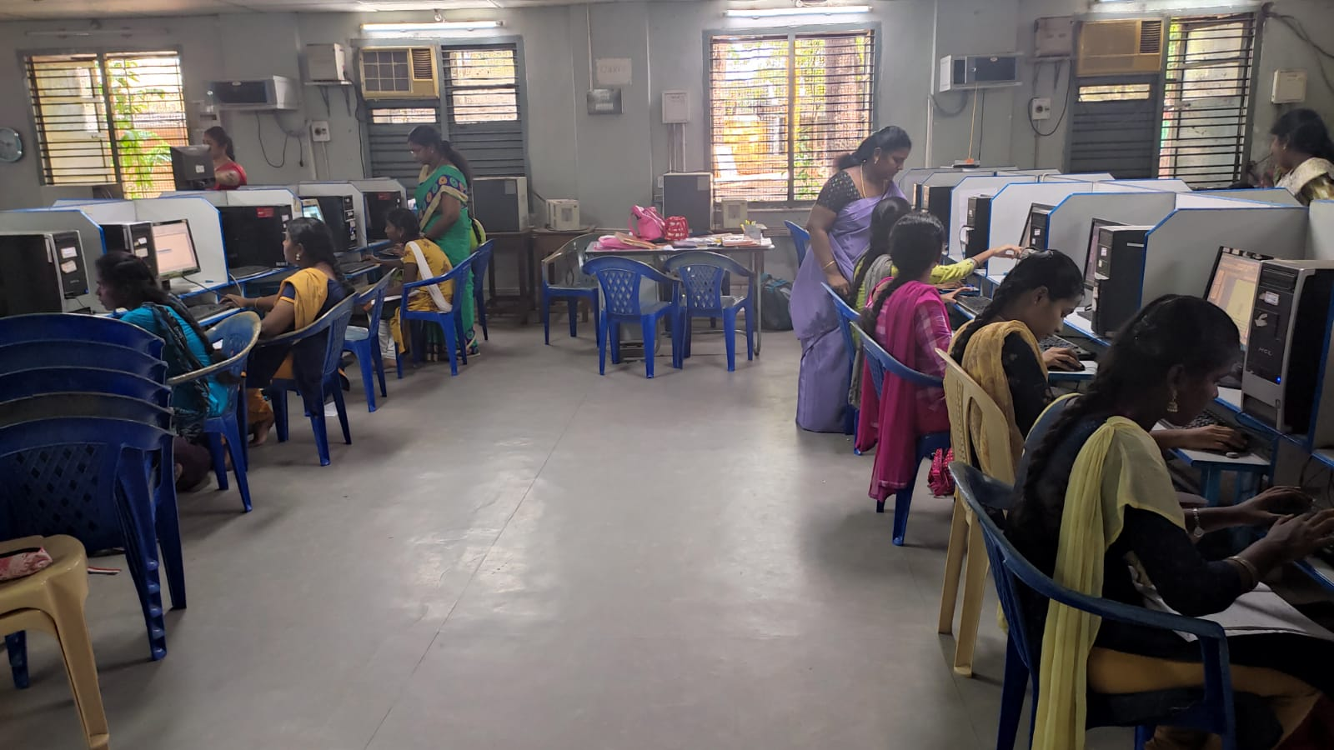

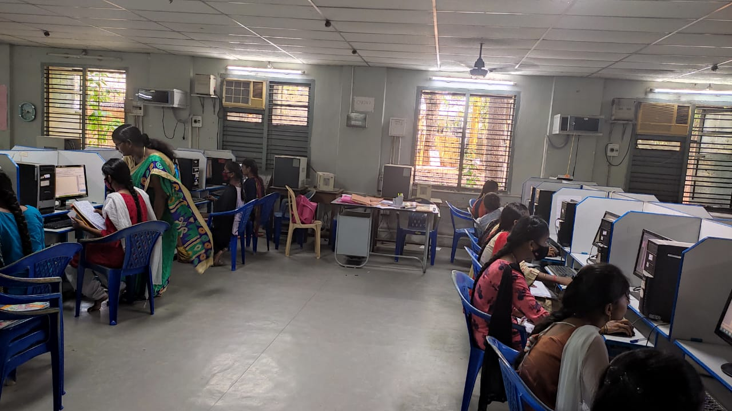

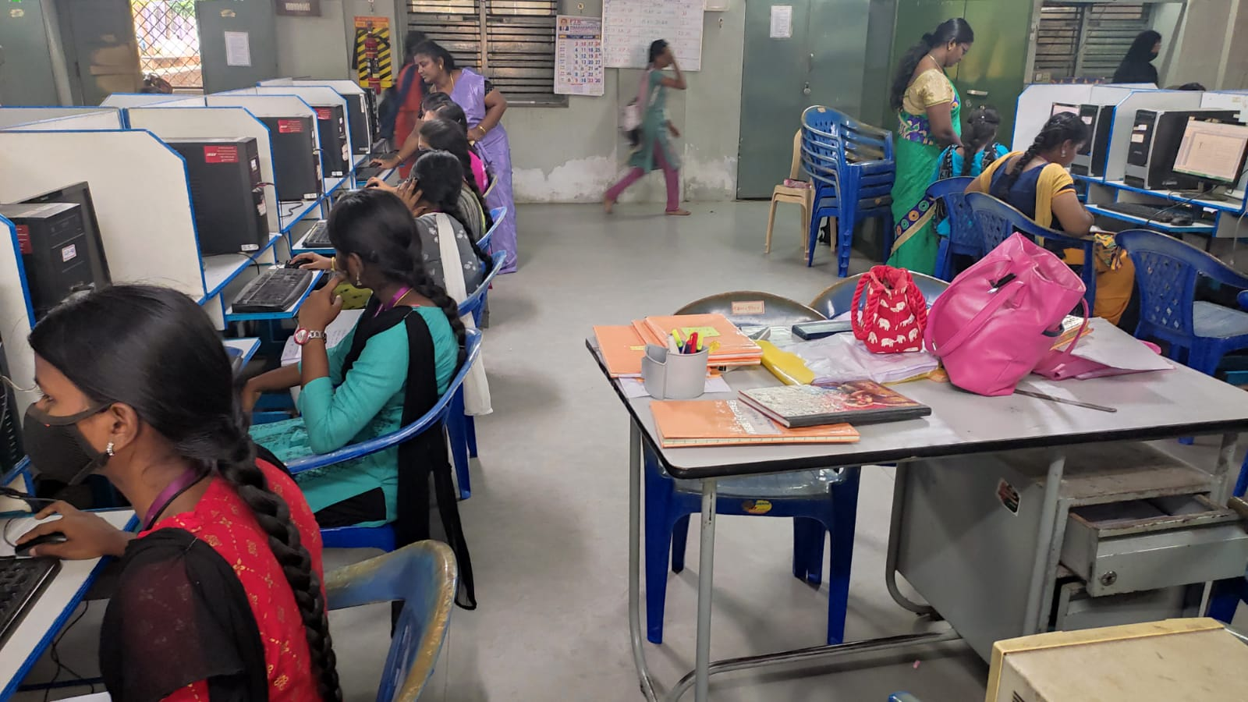

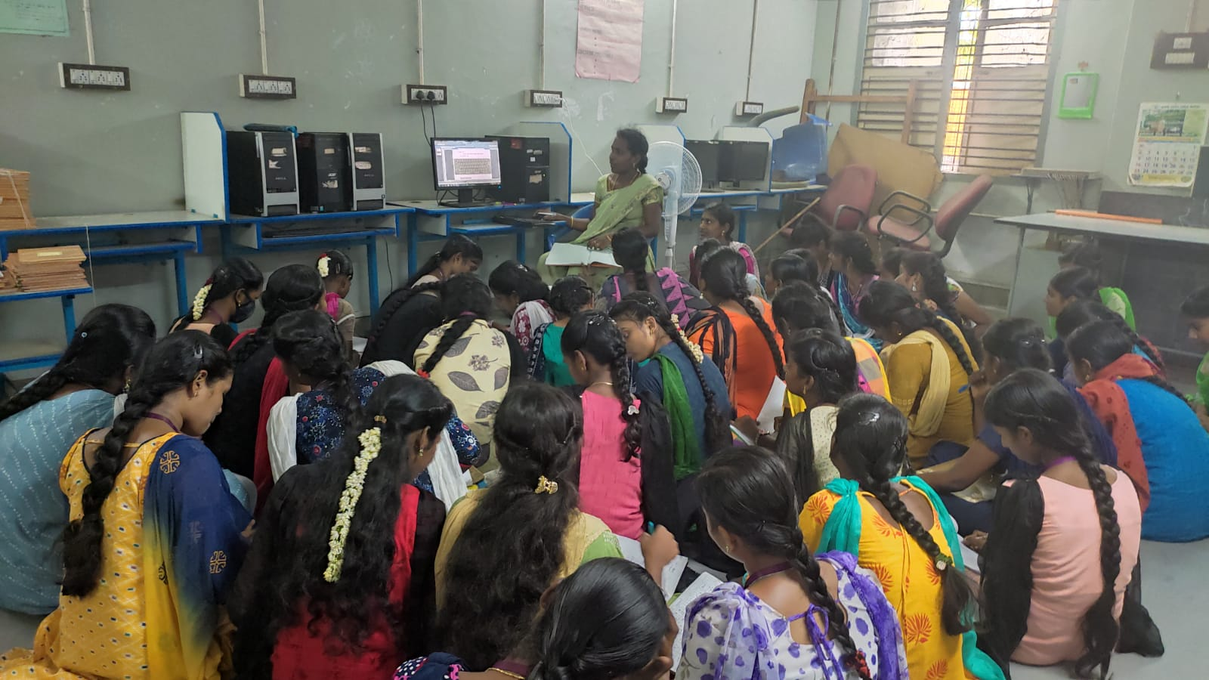

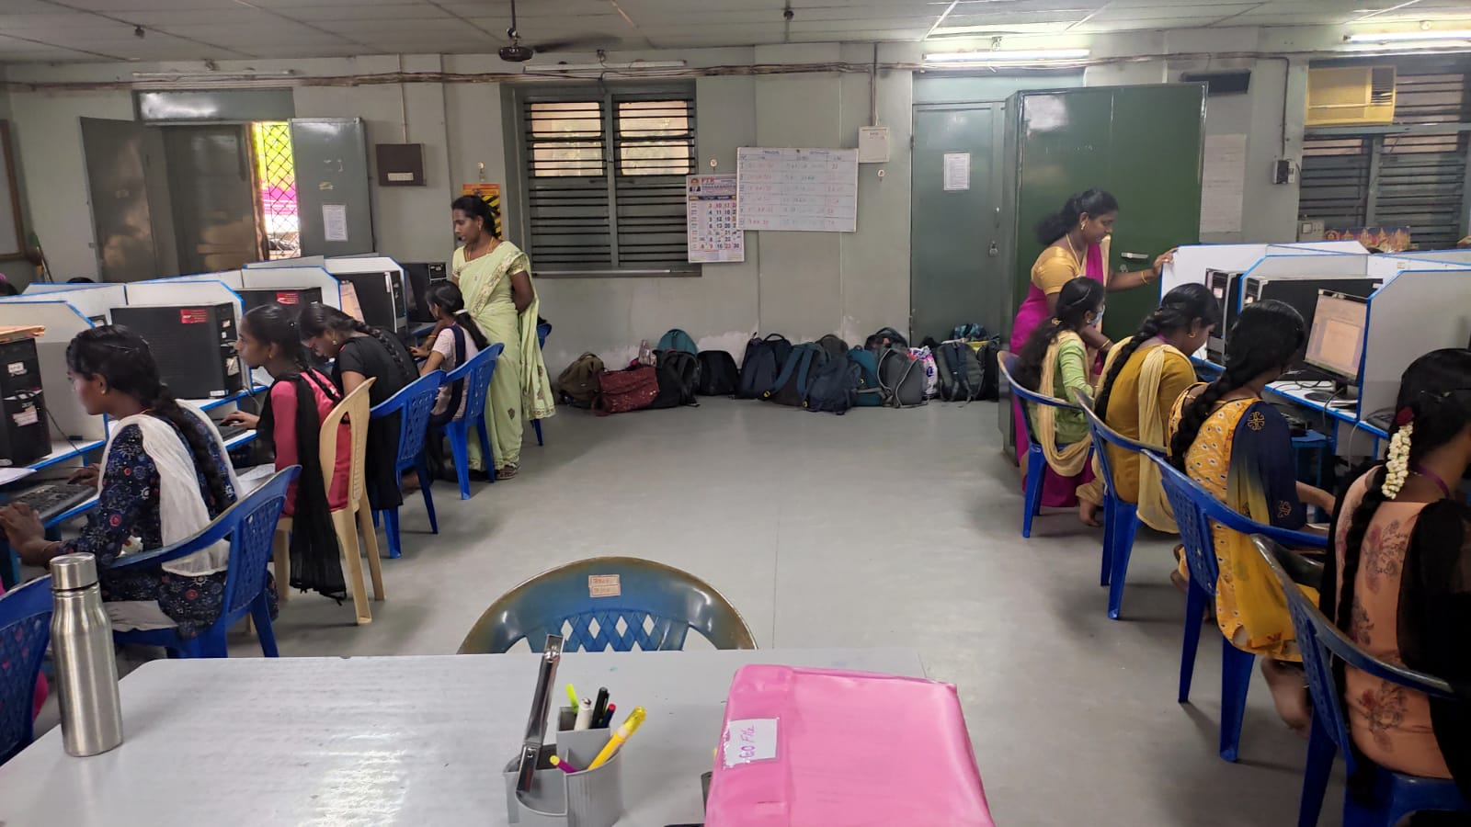

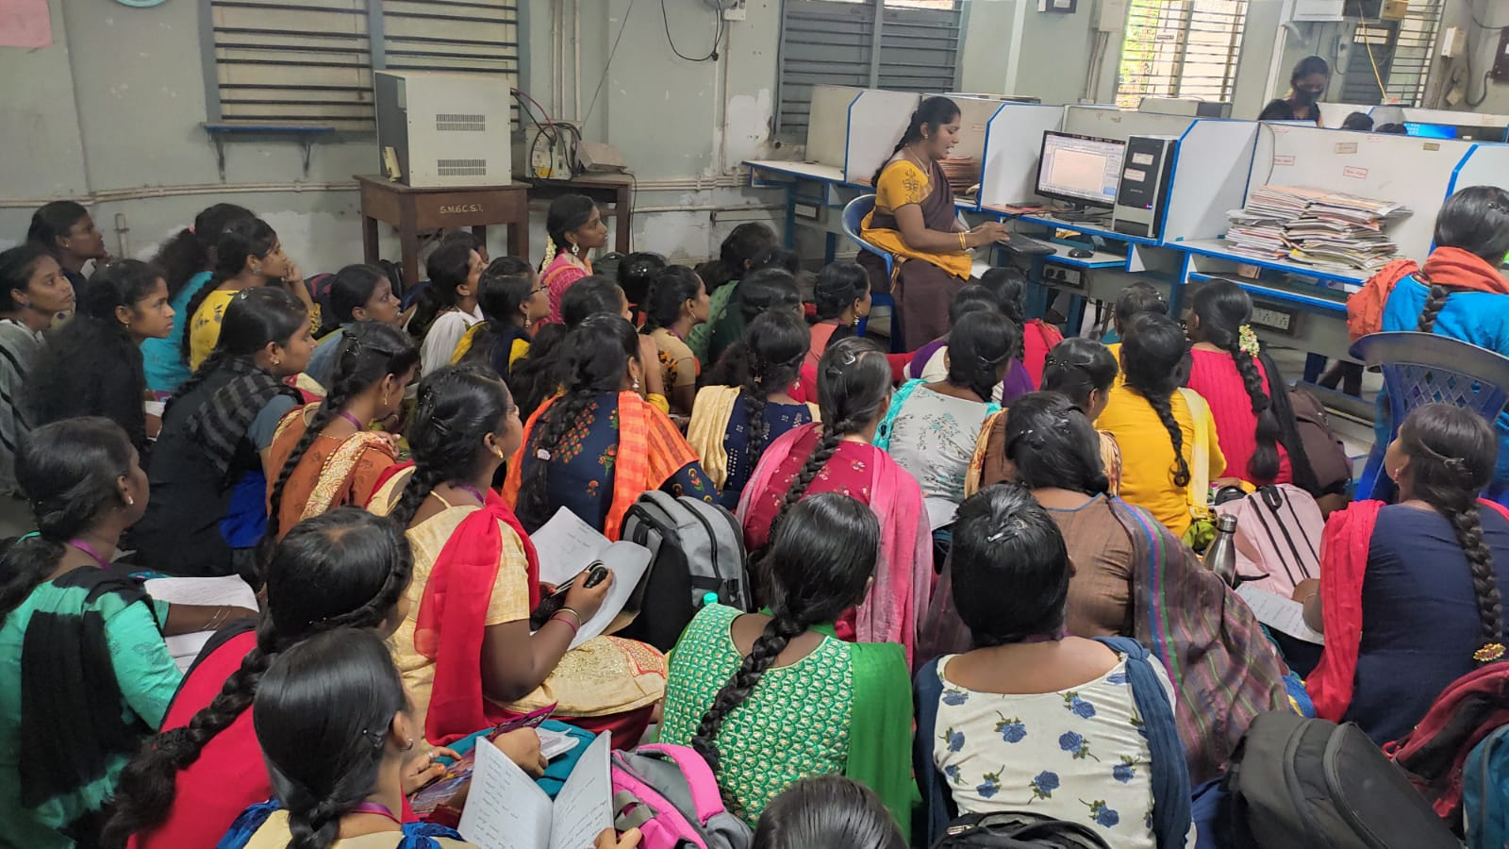

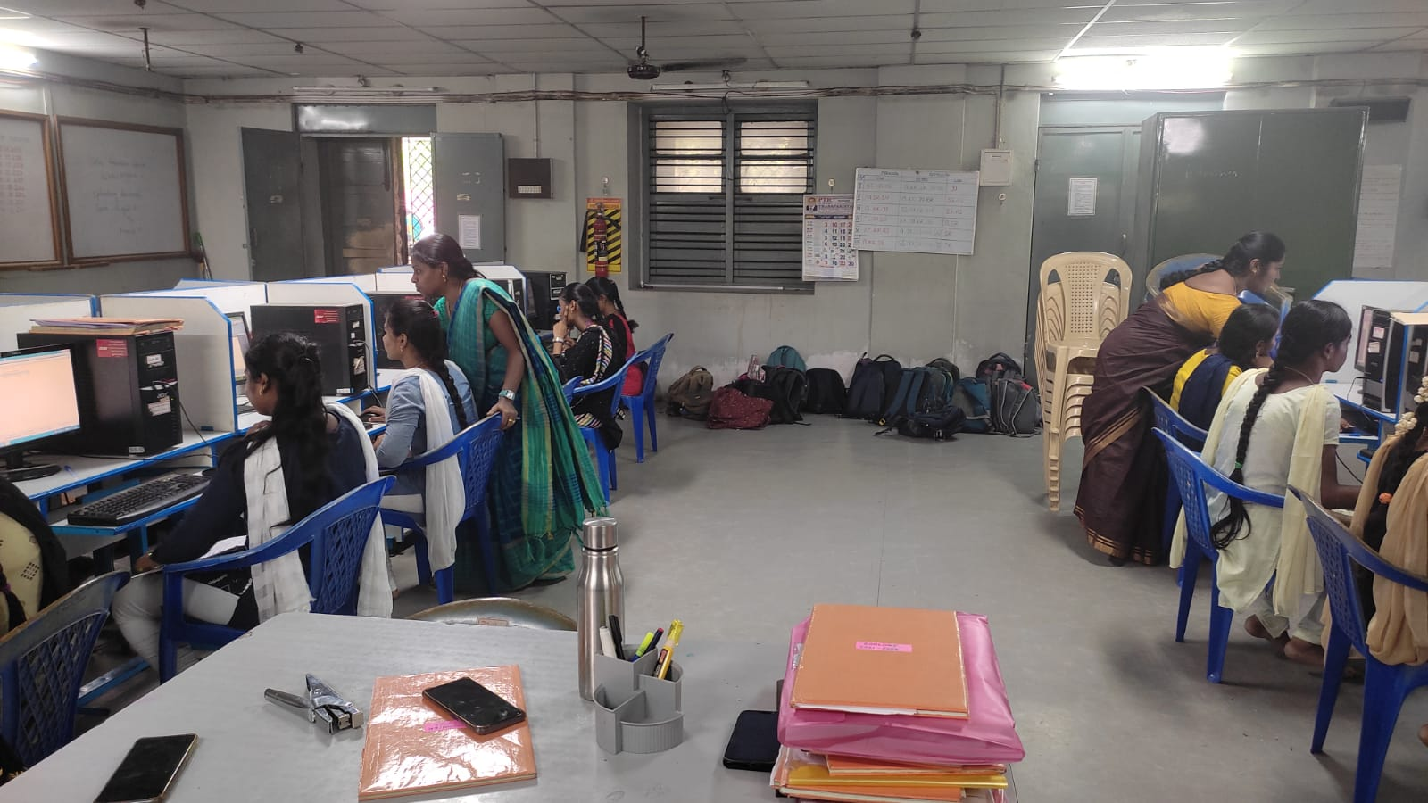

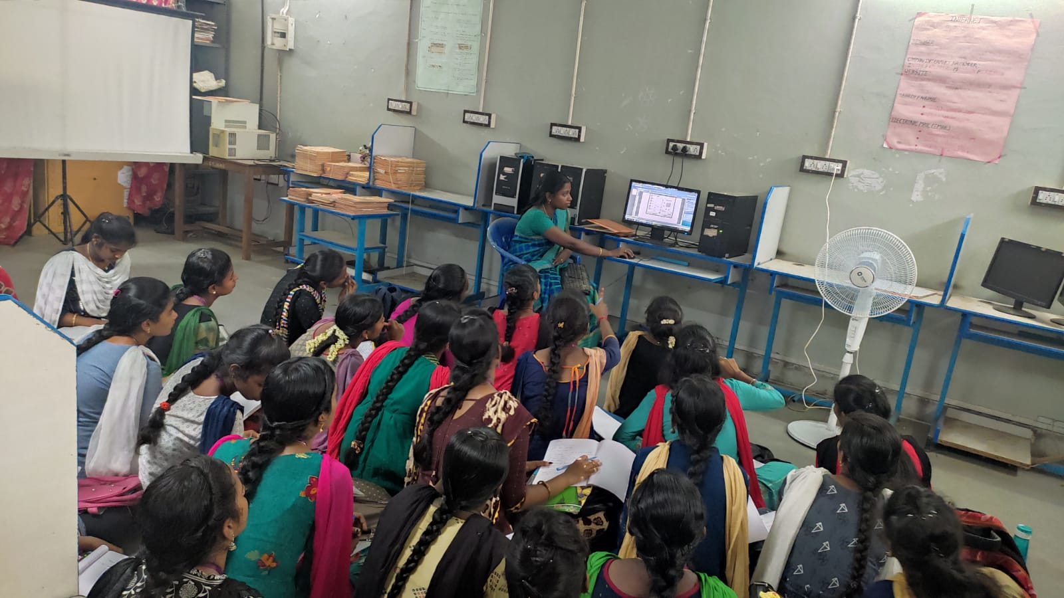

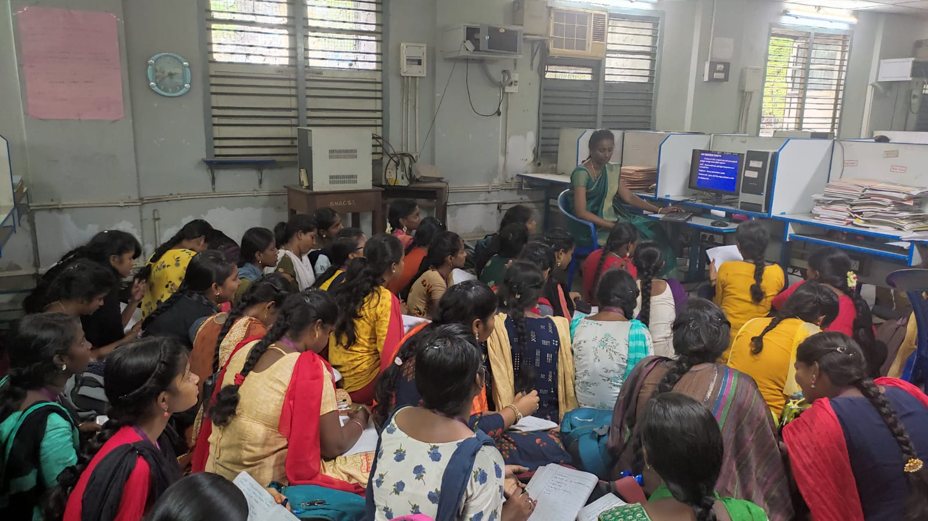

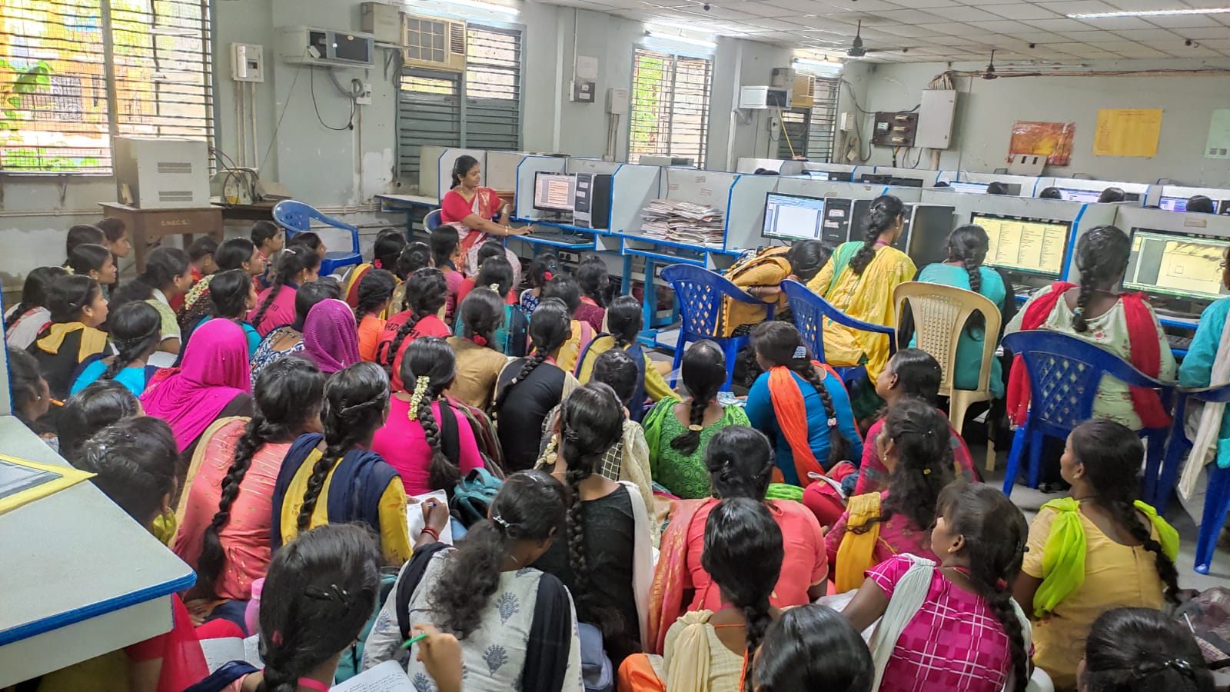

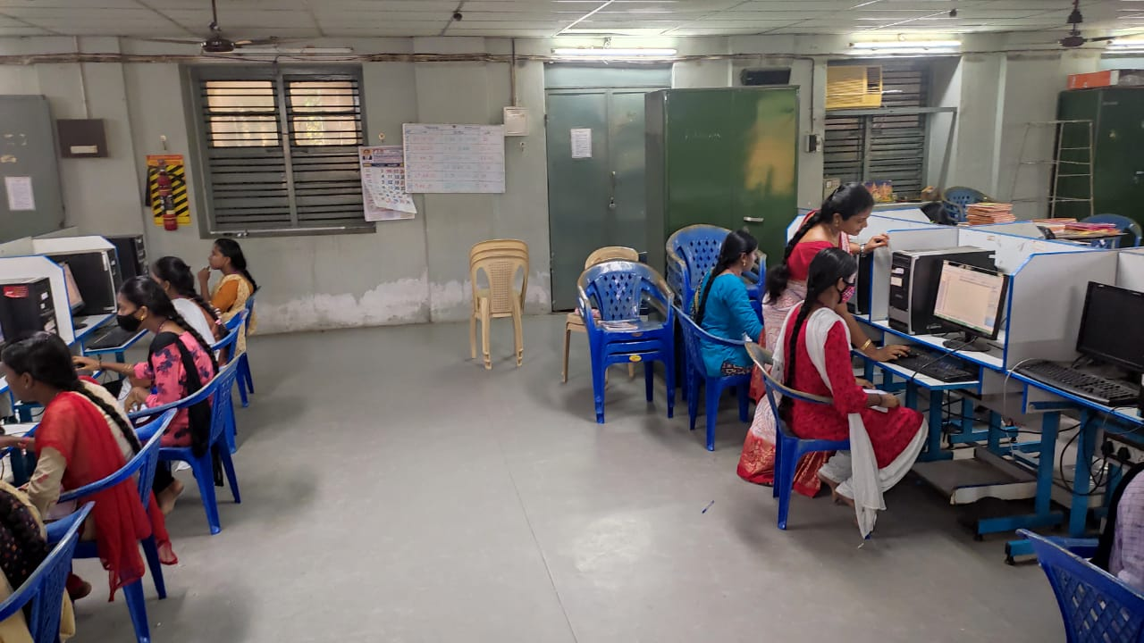

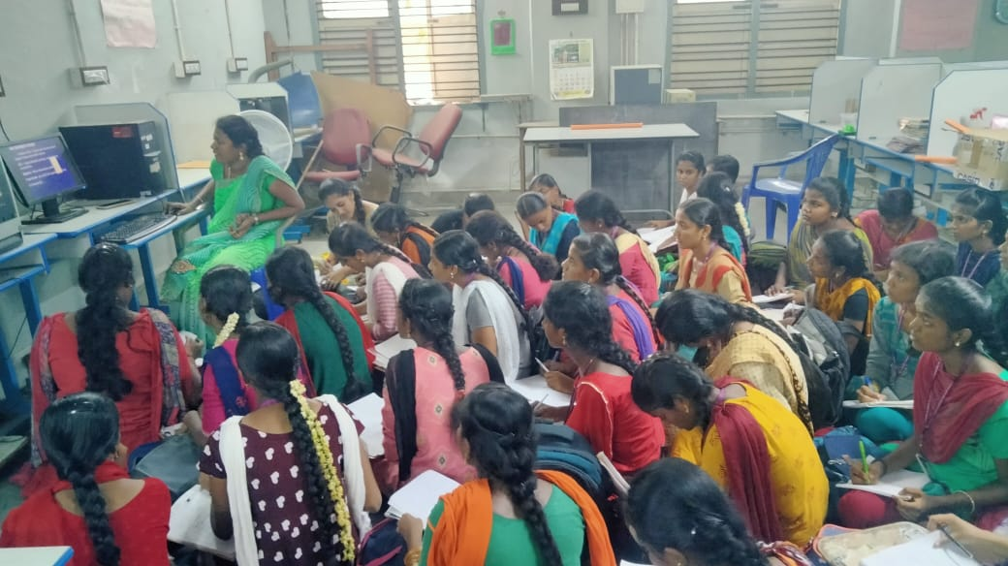

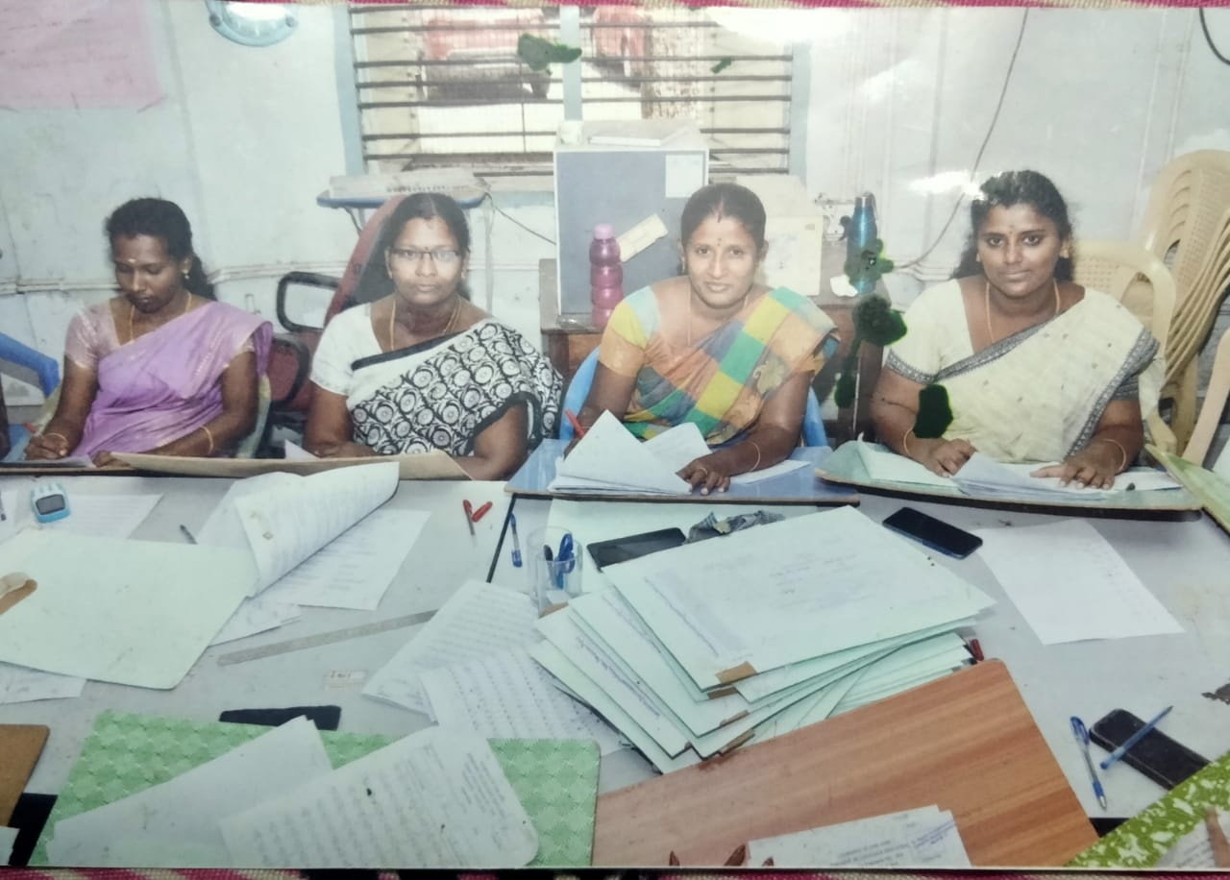

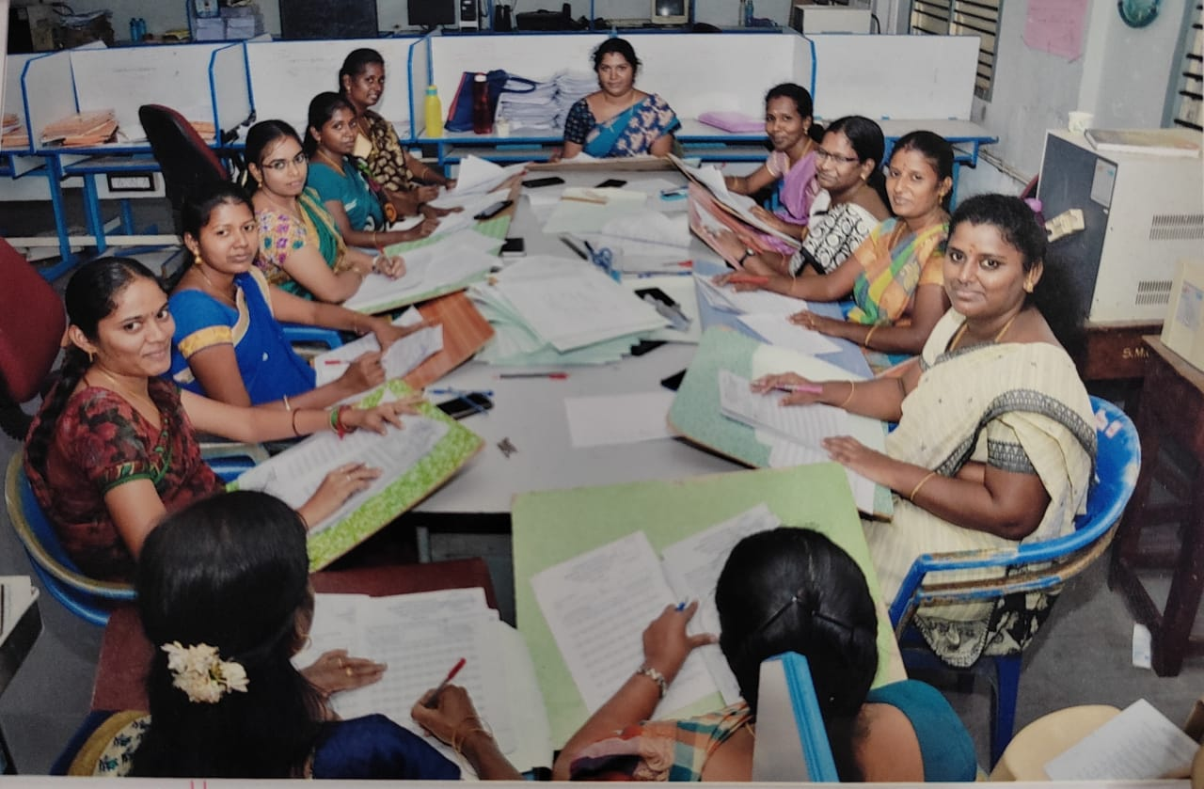

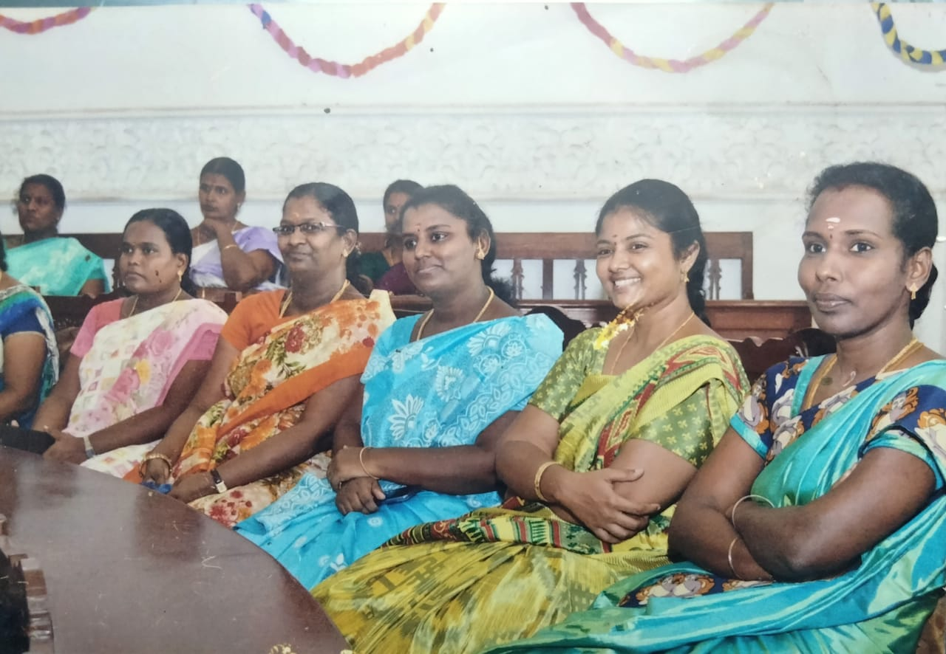

CLP CERTIFICATE
