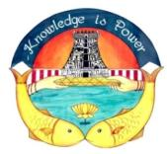
SRI MEENAKSHI GOVERNMENT ARTS COLLEGE FOR WOMEN (AUTONOMOUS), MADURAI – 625 002
Re-Accredited with “A” Grade in 3rd CYCLE by NAAC

7.1.3 E-WASTE MANAGEMENT
The college follows the concept of reduce, reuse and recycle
- To keep the campus eco-friendly the college will not stock obsolete and unusable electronic devices.
- The buyback policy of the retailers will be utilized for purchase of new computers and batteries for out dated/modelled computers and old batteries
- In a phased-out manner, batteries that doesn’t need refilling of distilled water will be used.

- Solid Waste Management
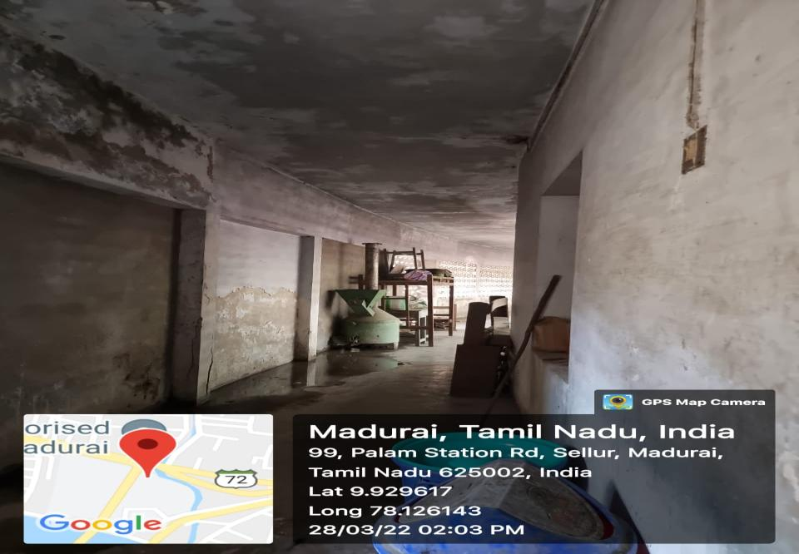
Safe disposal of napkins by use of incinerator in the hostel

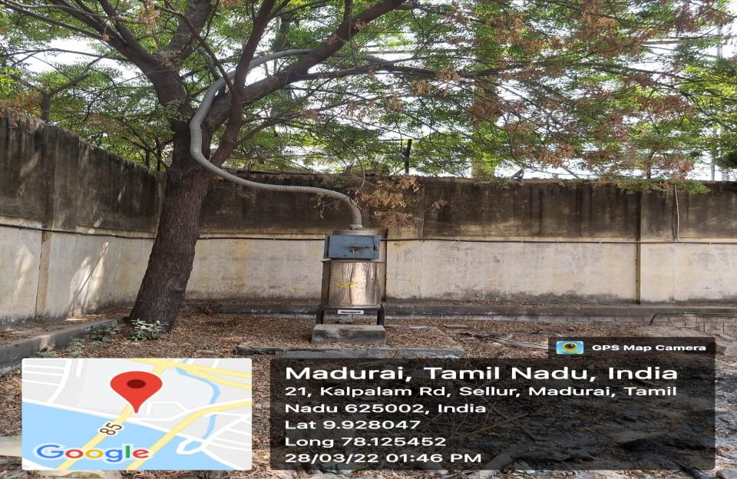
Safe disposal of napkins by use of incinerator in the campus
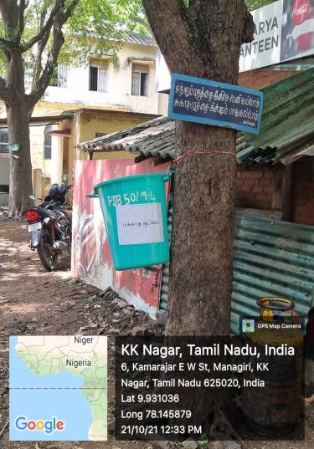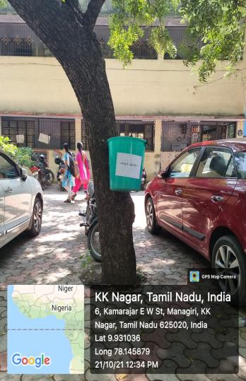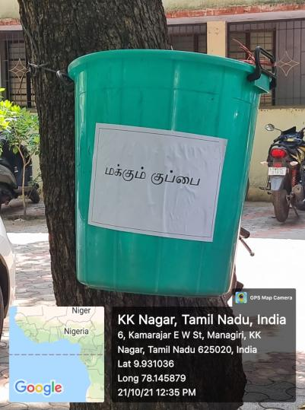

DUSTBINS ARE PROVIDED FOR DEGRADABLE AND NON-DEGRADABLE WASTE NEAR THE CANTEENS

- Liquid Waste management 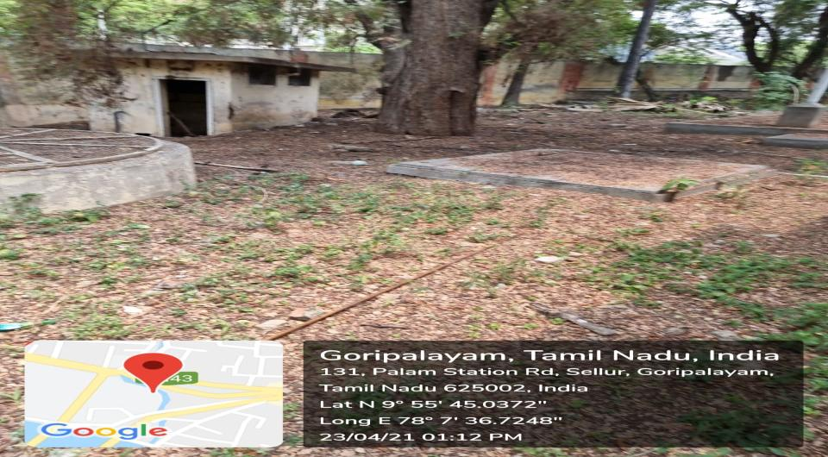
Liquid waste from the washrooms is connected to sceptic tanks & then to the Underground Drainage system of Madurai Corporation.

