BIO DATA
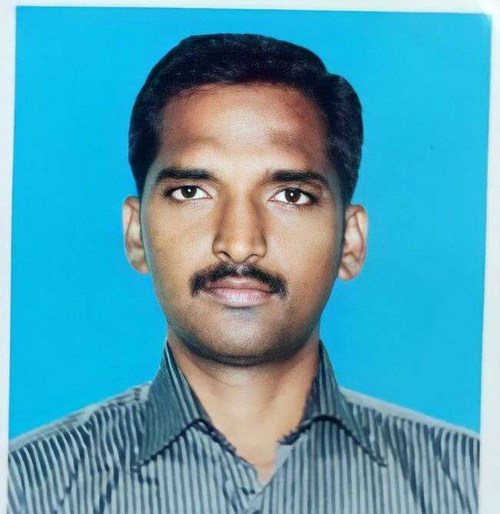

1. Name : Dr. C. INBAM
2. Qualification : M.Sc., M. Phil., Ph.D.,
3. Designation & Department : Assistant Professor, Mathematics
4. Age & Date Of Birth : 44 & 01.06.1978
5. Sex : Male
6. Permanent Address : 4/139-2,Kovil Street, Kurinji Nagar, Aathikulam,
Madurai -14.
7. Address For Communication : 4/139-2,Kovil Street, Kurinji Nagar, Aathikulam,
Madurai -14.
8. Educational Qualification :

S. No. | Courses | Subject | Year Of Completion | Institution
1 | M.Sc., | Mathematics | 2000 | ThiagarajarCollege, Madurai.
2 | M.Phil., | Mathematics | 2002 | AnnamalaiUniversity, Chidambaram.
3 | Ph.D., | Mathematics | 2004 | Annamalai University, Chidambaram.

9. Research Work / Experience : 12 years
10. Recognized Research guide : No
11. Area of Specialization : Graph Theory
12. Teaching Experience:

S. No. | Designation | Place | Duration | No. Of Years
1 | Assistant Professor | Sri Meenakshi Govt. Arts College for Women (A), Madurai - 02 | 07-03-2023 to till Date (20-03-2023)
2 | Assistant Professor | Government Arts College, Melur | 11-09-2014  to  07-03-2023 | 8
3 | Assistant Professor | Raja Doraisingam Government Arts College, Sivagangai | 14-08-2010  to  10-09-2014 | 5
4 | Assistant Professor | Government Arts College, Ariyalur | 09-07-2009  to  13-08-2010 | 1
Total Teaching Experience |  |  |  | 14

13. Orientation / Refresher Courses / Other Programmes &Training :

S. No. | Name of the Course | Topic | Place | Period
1 | Orientation | Intensive Training | UGC-ASC - University of Madras, Chennai | 09-07-2009  to  05-08-2009
2 | Orientation | National Service Scheme (NSS) | Avinashilingam Institute for Home Science and Higher Education for Women, Coimbatore | 13-11-2019  to  19-11-2019
3 | Refresher | Recent Trends in Advanced Mathematics | ASC - M. K. University, Madurai | 23-02-2011  to  15-03-2011
4 | Refresher | Recent Trends in Environmental Studies | HRDC - M. K. University, Madurai | 09-03-2018  to  29-03-2018
5 | Refresher | Learning Outcomes and Educational Reforms: Pedagogy, Assessment and Quality Assurance | HRDC – Bharathidasan University,  Tiruchirappalli | 24-02-2021  to  09-03-2021

14. International Publications :

S. No. | Journal | Title | Period
1 | International Journal of Emerging Technologies and Innovative Research (www.jetir.org), ISSN:2349-5162 | ECO-MATHEMATICS- A STUDY ON INTERPRETING NATURE WITH MATHEMATICS | Volume – 12, Issue: 70, February 2022
2 | International Journal of Emerging Technologies and Innovative Researchwww.jetir.org| UGC Approved, ISSN:2349- 5162 | A STUDY ON CACHE CONSISTENCY MAINTENANCE IN CLOUDCOMPUTING DATABASES | Vol.7, Issue 3, page no. pp1-4, March 2020
3 | International Journal of Civil Engineering and Technology (IJCIET) SCOPUS Indexed ISSN Print: 0976-6308 and ISSN Online: 0976- 6316 | A NEW APPROACH FOR SOLVING UNCERTAINTY NONLINEAR EQUATIONS USING FALSE POSITION METHOD | Volume 10, Issue 01, January 2019, pp. 1390-1395, Article ID: IJCIET_10_01_127
4 | International Journal of IT, Engineering and Applied Sciences Research (IJIEASR) | THE CLIQUE REGULAR DOMINATION NUMBER IN FUZZY GRAPHS | Volume 7, No. 1, January 2018

15. National Publications :

S. No. | Journal | Title | Period
1 | Indian Journal of Natural Sciences (IJONS), ISSN: 0976-0997 Web of Science Indexed, Thomson Reuters, USA | ON D^-CLOSED SETS IN IDEAL TOPOLOGICAL SPACES | Volume – 12, Issue: 70, February 2022
2 | Journal of Information and Computational Science SCOPUS Indexed www.joics.org ISSN: 1548-7741 | AN IMPROVED HOHMOMORPHIC ENCRYPTION SCHEME FOR CLOUD DATA COMBING WITH GWO ALGORITHM | Volume 9 Issue 9 – 2019
3 | ADALYA JOURNAL  ISSN NO: 1301-2746 Page No : 956 – 963 SCOPUS Indexed DOI:16.10089.AJ.2019. V8I9.285311.6213 | A LION OPTIMIZATION ALGORITHM FOR AN EFFICIENT CLOUD COMPUTING WITH HIGH SECURITY | Volume 8, Issue 9, September 2019
4 | ADALYA JOURNAL http://adalyajournal.com Page No: 945 – 955 SCOPUS Indexed DOI:16.10089.AJ.2019. V8I9.285311.6212 | A CLOUD-BASED DATA SEGMENTATION AND REPLICATION TECHNIQUE FOR HEALTH DATA AND IMAGE SECURITY | Volume 8, Issue 9, September 2019 ISSN NO: 1301-2746
5 | The Journal of Fuzzy Mathematics | THE MINUS PARTIAL ORDER IN FUZZY MATRICES | Volume 12, No. 3,  2004, pg. 695-700, ISSN : 1066 - 8950
6 | Journal of Annamalai University | THE DRAZIN INVERSE OF FUZZY MATRICES | Part-B, Science, pp: 1-12,2004
7 | The Journal of Fuzzy Mathematics | FUZZY MATRICES AND LINEAR TRANSFORMATION ON FUZZY VECTOR SPACES | Volume 11, No. 4,  2003, pg. 955-966, ISSN : 1066 - 8950

16. International / National / State Level Conference Participated

S. No. | Conference | Title | Place | Period
1 | International Conference on Emerging Trends in Engineering and Technology (ICETET’18) | RAST (Rapid Adaptive Super – Resolution Technique) | Pandian Saraswathi Yadav Engineering College, Madurai | 09.03.2018

17. Seminar / Symposia / Workshop Attended :

S. No. | Name & Level of the Programme | Title | Place | Period
1 | Two weeks online Faculty Development Programme | Pedagogy and Research Methods | HRDC and IQAC, AMET | 24.05.2021  to  06.06.2021
2 | Internal Quality Assurance Cell | Role of Soft skills in Career Development | Government Arts College for Women (Autonomous), Pudukkottai | 09.06.2021
3 | Department of Computer Science | Machine Learning Methods and Applications in Research | Government Arts College for Women (Autonomous), Pudukkottai | 06.07.2021
4 | National Seminar on Graph Theory and Fuzzy Mathematics | Sharp ordering on fuzzy matrices | Catholicate College, Makkamkunnu, Mannaramala, Pathanamthitta, Kerala, | 28.08.2003

18. Other responsibilities hold in service( Current/ Previous):

S. No. | NAME OF THE SERVICE/COMMITTEE | PLACE | PERIOD
1 | Member of Departmental Admission Committee | Government Arts College, Melur | 2018-2021
2 | Stock verification Committee | Government Arts College, Melur | 2018-2021
3 | Sports Committee | Government Arts College, Melur | 2018-2021
4 | NSS Programme Officer | Government Arts College, Melur | 2018-2021

